LAB asseSSment 3 (LA3) soft-record
BCSE203E: Web Programming Lab
Programme: B.Tech ; Branch: CSE
Class number: VL2025260504864;
Slot: L33+L34/L59+L60
Time: 15:51 – 17:30/17:40 – 19:20
VENUE: PRP232

Reg No: <24Bai0158>
Name: <Vihaan Varshney >


School of Computer Science and Engineering

Assessment:  Date: | Problem Statement-1
Create a simple web page that displays "Hello, world!" when a button is clicked. Use JavaScript function, DOM manipulation with getElementById, and outerHTML property.
Concepts:
  - Variables (var)
  - Function declaration
  - DOM access (document.getElementById)
  - outerHTML property
  - Event handling (onclick)

List of tags used | List of tags Description  body Defines the document's body, containing all visible content.  br Inserts a single line break.  button Defines a clickable button.  h1 Defines the most important heading.  h3 Defines a third-level heading.  head Contains meta-information about the HTML page.  html The root element of an HTML page.  meta Defines metadata about an HTML document.  p Defines a paragraph.  script Used to embed or reference executable code (typically JavaScript).  title Specifies a title for the HTML page.
Program | <!DOCTYPE html>  <html lang="en">  <head>  <meta charset="UTF-8">  <title>Print Hello World</title>  <script>  // Function declaration that runs when button is clicked  function helloWorld(){  // Access the HTML element with id "output"  // outerHTML replaces the element itself with new content  // "+=" appends the new text instead of replacing everything  document.getElementById("output").outerHTML += "Hello World" + "<br>";  }  </script>  </head>  <body>  <!-- Heading for the webpage -->  <h1>Print Hello World</h1>  <!-- Button that triggers the JavaScript function when clicked -->  <button id="print" onclick="helloWorld();">Hello World</button>  <!-- Empty element where the output will appear -->  <h3 id="output"></h3>  <p>VIHAAN VARSHNEY 24BAI0158</p>  </body>  </html>
Output Screenshots | 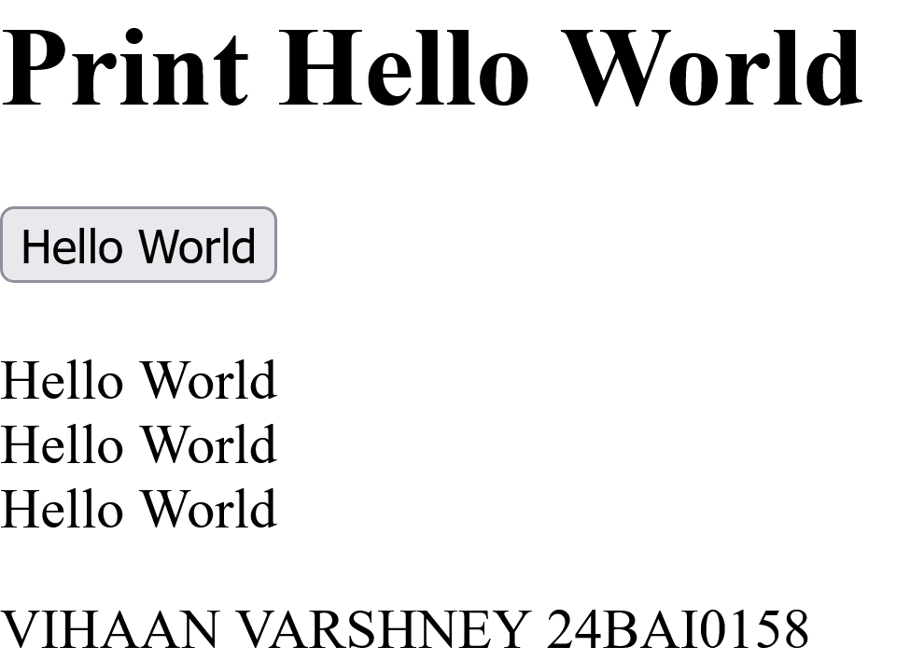
Observations | 1. The webpage uses an `onclick` event to trigger the JavaScript function when the button is clicked.  2. The function accesses the DOM element using `document.getElementById("output")`.  3. The `outerHTML` property is used to modify the HTML element and append the text "Hello World".  4. Each button click adds "Hello World" followed by a line break (`<br>`), allowing multiple outputs.  5. The program demonstrates interaction between HTML structure and JavaScript for dynamic content updates.
References

Assessment:  Date: | Problem Statement-2
Create a web page with three different buttons that change the background color to red, green, and blue respectively when clicked.
Concepts:
  - Button controls (type="button")
  - Function with parameters
  - document.body.style.backgroundColor
  - Event handlers (onclick)

List of tags used | List of tags Description  body Defines the document's body, containing all visible content.  h1 Defines the most important heading.  head Contains meta-information about the HTML page.  html The root element of an HTML page.  input Defines an input control (e.g., button, text field).  meta Defines metadata about an HTML document.  p Defines a paragraph.  script Used to embed or reference executable code (typically JavaScript).  title Specifies a title for the HTML page.
Program | <!DOCTYPE html>  <html lang="en">  <head>  <meta charset="UTF-8">  <title>Change Color</title>  <script>  // Function that changes the background color  // The color value is received as a parameter  function changeColor(color){  // Changes the background color of the entire webpage  document.body.style.backgroundColor = color;  }  </script>  </head>  <body>  <!-- Heading for the webpage -->  <h1>Change Background-Color</h1>  <!-- Button to change background color to red -->  <input type="button" value="Red" onclick="changeColor('red');">  <!-- Button to change background color to blue -->  <input type="button" value="Blue" onclick="changeColor('blue');">  <!-- Button to change background color to green -->  <input type="button" value="Green" onclick="changeColor('green');">  <p>VIHAAN VARSHNEY 24BAI0158</p>  </body>  </html>
Output Screenshots | 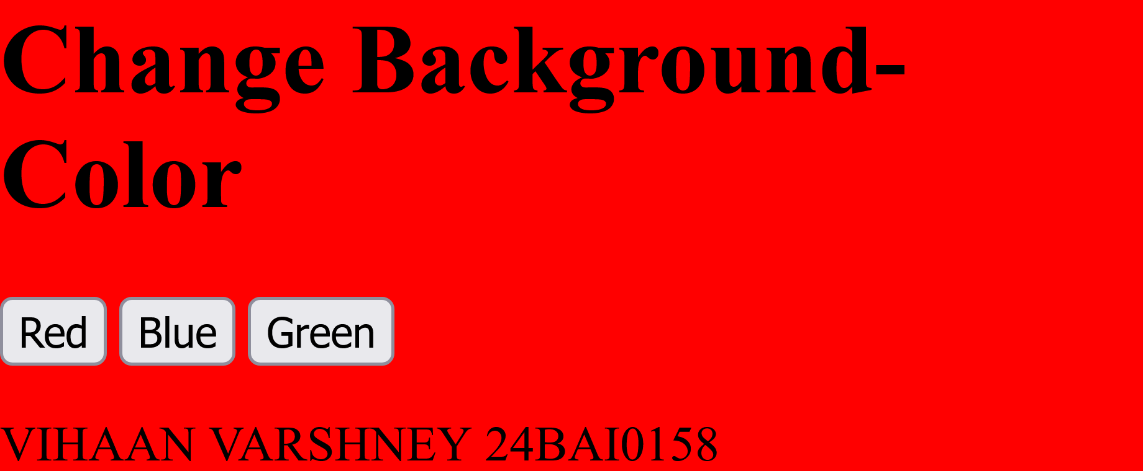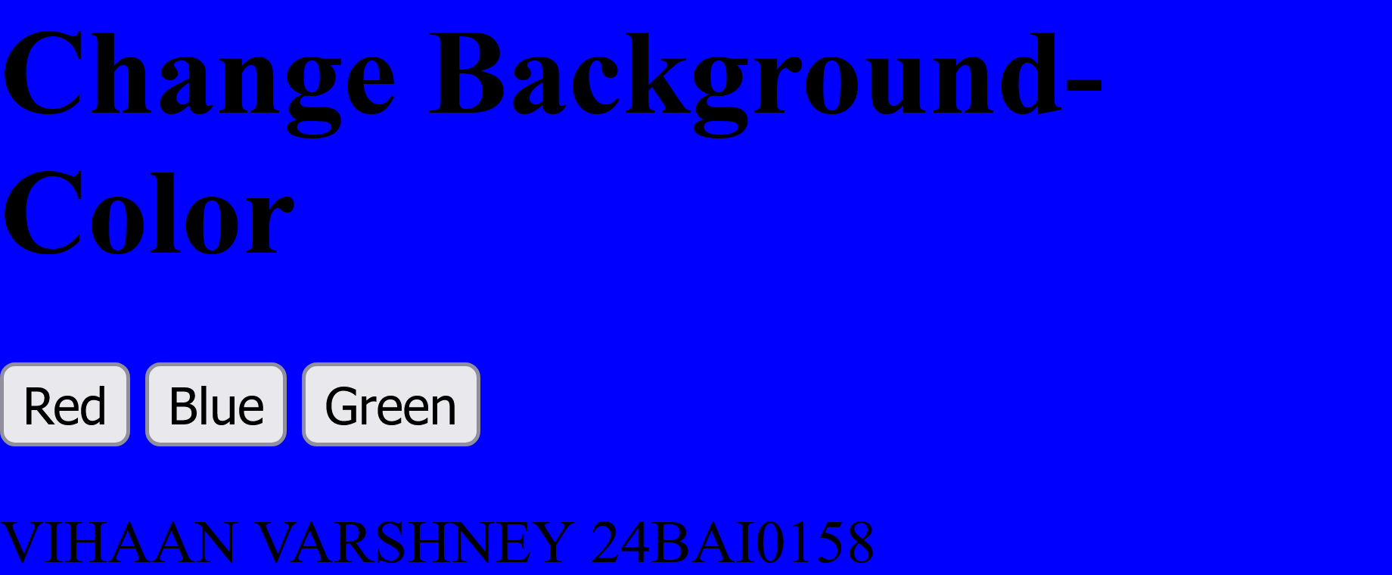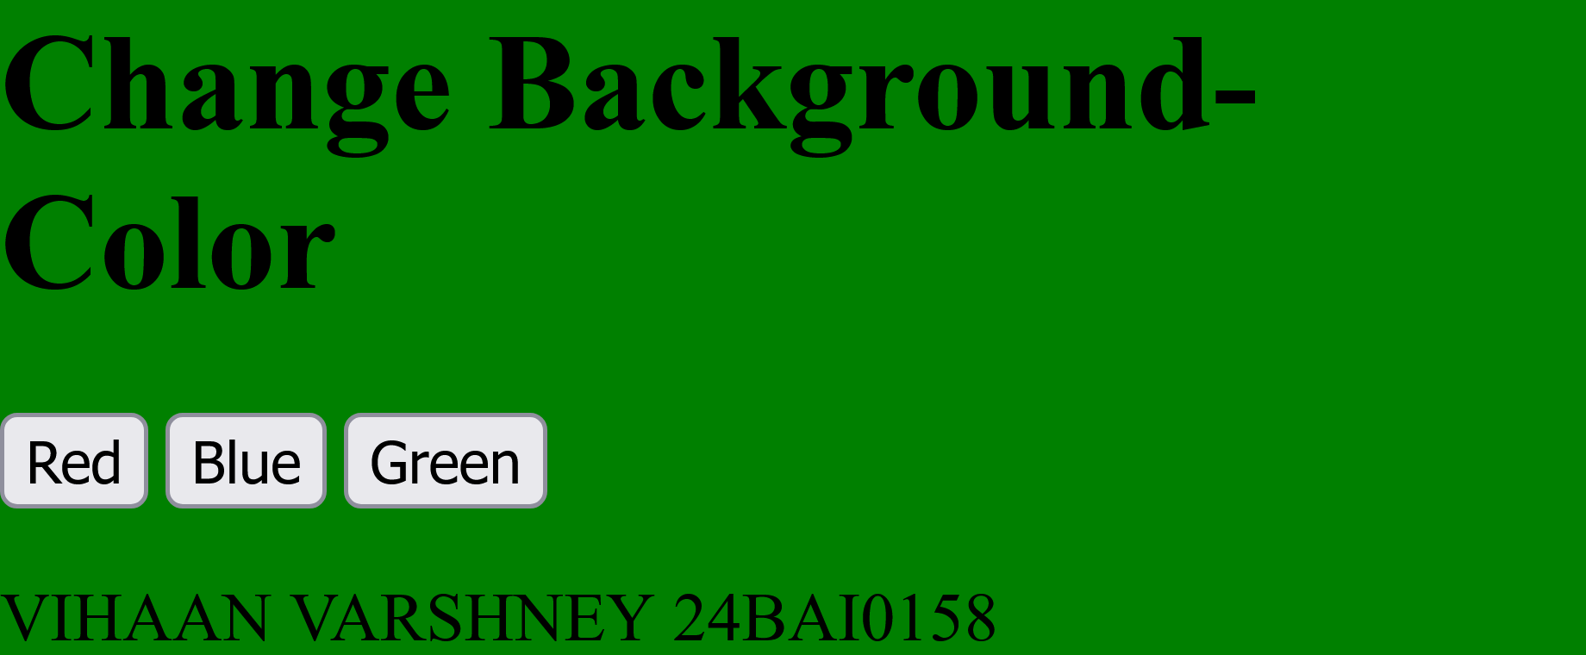
Observations | 1. The webpage uses input buttons with `type="button"` to trigger JavaScript functions.  2. A single function `changeColor(color)` is used with a parameter to handle multiple color changes.  3. The background color of the webpage is modified using `document.body.style.backgroundColor`.  4. Each button calls the function using the `onclick` event handler.  5. The program demonstrates how JavaScript can dynamically change webpage styles.
References

Assessment:  Date: | Problem Statement-3
Create an Email Address Generator web page that takes first name and last name as input, generates an email address in the format "firstname.lastname@park.edu", displays it, clears the form, and sets focus back to the first name field.
Concepts:
  - form.elements access
  - String concatenation (+ operator)
  - innerHTML
  - reset() method
  - focus() method
  - this.form
List of tags used | List of tags Description  body Defines the document's body, containing all visible content.  br Inserts a single line break.  button Defines a clickable button.  form Defines an HTML form for user input.  h1 Defines the most important heading.  head Contains meta-information about the HTML page.  html The root element of an HTML page.  input Defines an input control.  label Defines a label for an <input> element.  meta Defines metadata about an HTML document.  p Defines a paragraph.  script Used to embed or reference executable code (typically JavaScript).  title Specifies a title for the HTML page.
Program | <!DOCTYPE html>  <html lang="en">  <head>  <meta charset="UTF-8">  <title>Email Generator</title>  <script>  // Function to generate the email address  // The form reference is passed using this.form  function genEmail(f){  // Store the form reference in a variable  let form = f;  // Access the first name value using form.elements  let first = form.elements["first"].value;  // Access the last name value using form.elements  let last = form.elements["last"].value;  // Generate email using string concatenation  // and display it inside the output element  document.getElementById("output").innerHTML =  first + "." + last + "@park.edu";  // Reset the form fields  form.reset();  // Set focus back to the first name field  form.elements["first"].focus();  }  </script>  </head>  <body>  <!-- Heading of the page -->  <h1>Email Generator</h1>  <!-- Form to collect first and last name -->  <form id="mainForm">  <!-- Input field for first name -->  <label>Firstname:</label>  <input id="first" type="text"><br>  <!-- Input field for last name -->  <label>Lastname:</label>  <input id="last" type="text"><br>  <!-- Button that calls the email generator function -->  <button type="button" onclick="genEmail(this.form);">  Generate Email  </button>  </form>  <!-- Area where the generated email will be displayed -->  <p id="output"></p>  <p>VIHAAN VARSHNEY 24BAI0158</p>  </body>  </html>
Output Screenshots | 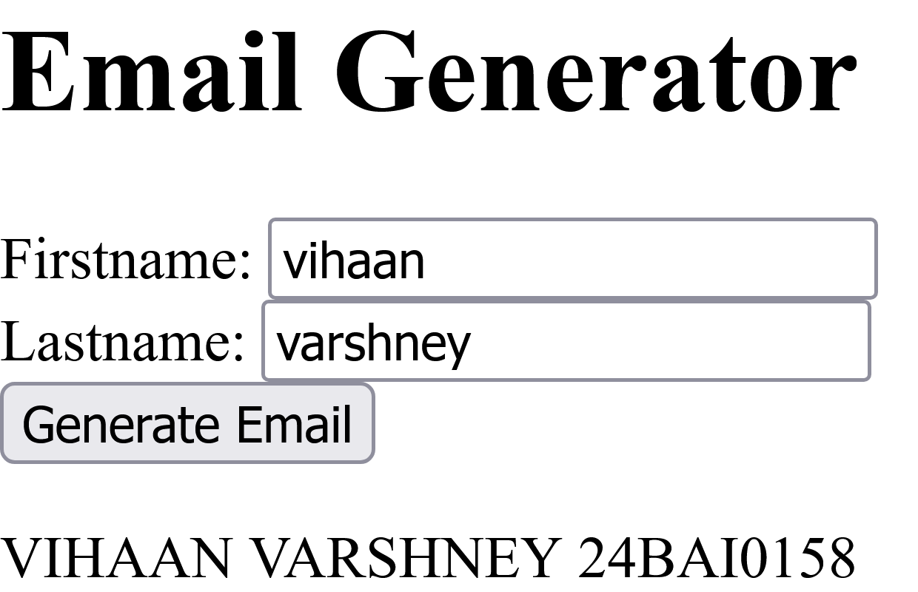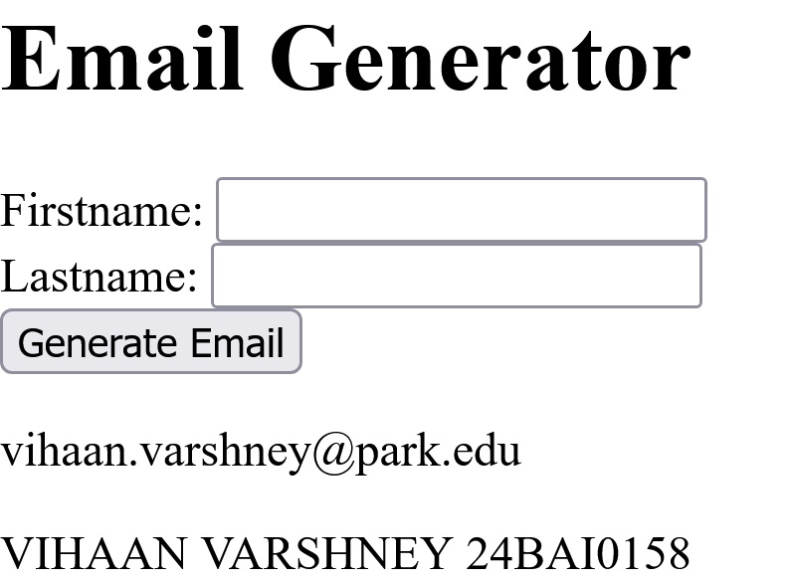
Observations | 1. The program accesses form inputs using `form.elements`.  2. The email address is created using string concatenation with the `+` operator.  3. The generated email is displayed on the webpage using `innerHTML`.  4. The `reset()` method clears the form fields after generating the email.  5. The `focus()` method automatically places the cursor back in the first name field for new input.
References

Assessment:  Date: | Problem Statement-4
Write a JavaScript program that calculates the area of a rectangle. Use proper variable naming conventions (camelCase) and demonstrate loose typing by first calculating with integers, then with floating-point numbers.
- Concepts:
  - Variable declaration (var)
  - camelCase naming convention
  - Loose typing (dynamic typing)
  - Integer and float calculations
  - innerHTML
List of tags used | List of tags Description  body Defines the document's body, containing all visible content.  br Inserts a single line break.  h2 Defines a second-level heading.  head Contains meta-information about the HTML page.  html The root element of an HTML page.  input Defines an input control.  p Defines a paragraph.  script Used to embed or reference executable code.  title Specifies a title for the HTML page.
Program | <html>  <head>  <title>Rectangle Area</title>  <script>  // Function to calculate the area of a rectangle  function rectArea() {  // Get values entered by the user from input fields  var length = document.getElementById("length").value;  var breadth = document.getElementById("breadth").value;  // Integer calculation using parseInt()  var area = parseInt(length) * parseInt(breadth);  // Display the integer calculation result  document.getElementById("result").innerHTML =  "Area (Integer Calculation): " + area;  // Floating point calculation using parseFloat()  // Same variable 'area' reused (demonstrates loose typing)  area = parseFloat(length) * parseFloat(breadth);  // Append the floating point result to the previous output  document.getElementById("result").innerHTML +=  "<br>Area (Floating Point Calculation): " + area;  }  </script>  </head>  <body>  <!-- Page heading -->  <h2>Rectangle Area Calculator</h2>  <!-- Input field for rectangle length -->  Length: <input type="text" id="length"><br><br>  <!-- Input field for rectangle breadth -->  Breadth: <input type="text" id="breadth"><br><br>  <!-- Button to trigger the area calculation -->  <input type="button" value="Calculate Area" onclick="rectArea()">  <!-- Paragraph to display results -->  <p id="result"></p>  <p>VIHAAN VARSHNEY 24BAI0158</p>  </body>  </html>
Output Screenshots | 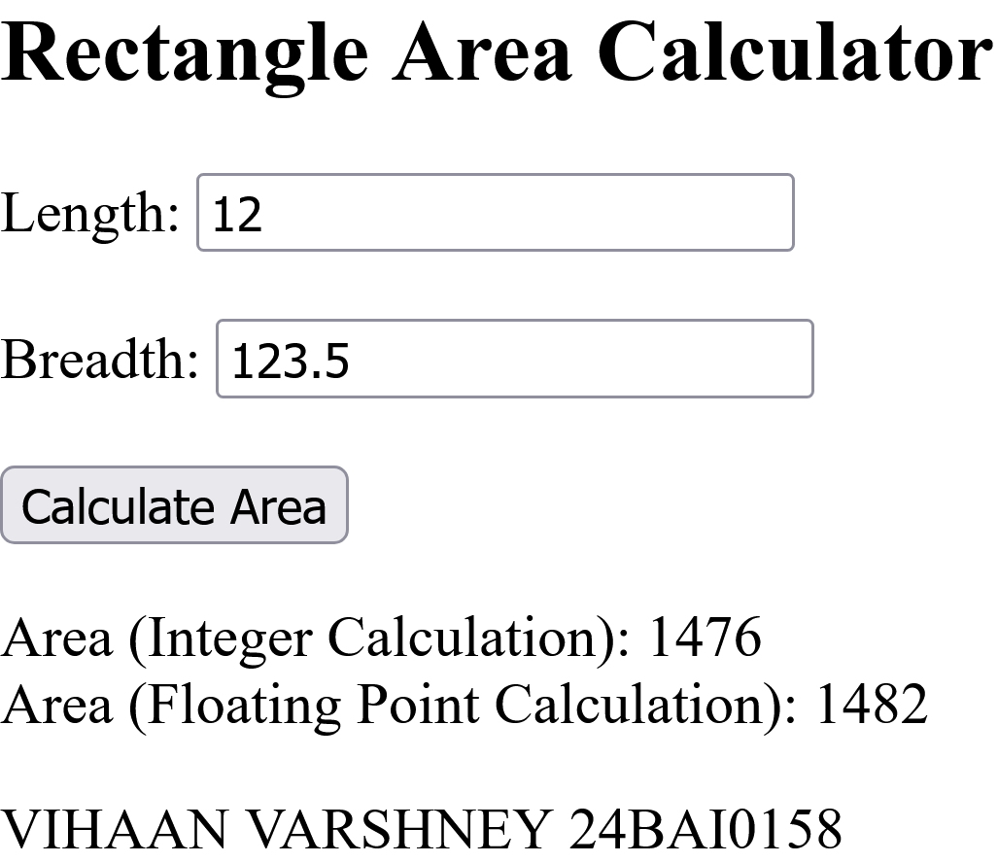
Observations | 1. The program declares variables using `var` and follows camelCase naming conventions.  2. User input values are accessed using `document.getElementById()`.  3. Integer area calculation is performed using `parseInt()`.  4. Floating-point calculation is performed using `parseFloat()` using the same variable `area`, demonstrating loose typing.  5. The calculated results are displayed dynamically on the webpage using `innerHTML`.
References

Assessment:  Date: | Problem Statement-5
Create a calculator that takes two numbers as input, performs addition, subtraction, multiplication, or division based on button clicked, and displays the result. Use number input type.
Concepts:
  - Number control (type="number")
  - step="any" attribute
  - parseFloat() function
  - switch statement
  - Division by zero handling
List of tags used | List of tags Description  body Defines the document's body, containing all visible content.  br Inserts a single line break.  head Contains meta-information about the HTML page.  html The root element of an HTML page.  input Defines an input control.  p Defines a paragraph.  script Used to embed or reference executable code.  title Specifies a title for the HTML page.
Program | <html>  <head>  <title>Calculator</title>  <script>  // Function to perform calculation based on the operator passed  function calValue(operator){  // Convert input values into floating point numbers  let a = parseFloat(document.getElementById("num1").value);  let b = parseFloat(document.getElementById("num2").value);  let result;  // Check if the inputs are valid numbers  if (isNaN(a) || isNaN(b)) {  document.getElementById("output").innerHTML =  "Please enter valid numbers";  return;  }  // Perform operation using switch statement  switch(operator){  case "+" :  result = a + b;  break;  case "-" :  result = a - b;  break;  case "*" :  result = a * b;  break;  case "/" :  // Handle division by zero  if(b === 0){  result = "Cannot divide by zero";  } else {  result = a / b;  }  break;  // Default case for unexpected operators  default:  result = "Invalid Operation";  }  // Display the result on the webpage  document.getElementById("output").innerHTML =  "Result: " + result;  }  </script>  </head>  <body>  <!-- Input field for first number -->  Number 1: <input type="number" id="num1" step="any"><br><br>  <!-- Input field for second number -->  Number 2: <input type="number" id="num2" step="any"><br><br>  <!-- Buttons to perform different arithmetic operations -->  <input type="button" value="Add" onclick="calValue('+')">  <input type="button" value="Sub" onclick="calValue('-')">  <input type="button" value="Mul" onclick="calValue('*')">  <input type="button" value="Div" onclick="calValue('/')">  <!-- Area to display the result -->  <p id="output">Result: </p>  <p>VIHAAN VARSHNEY 24BAI0158</p>  </body>  </html>
Output Screenshots | 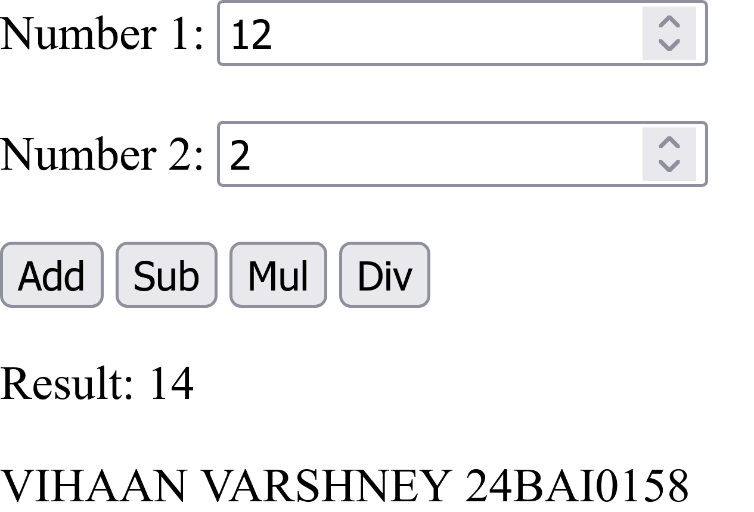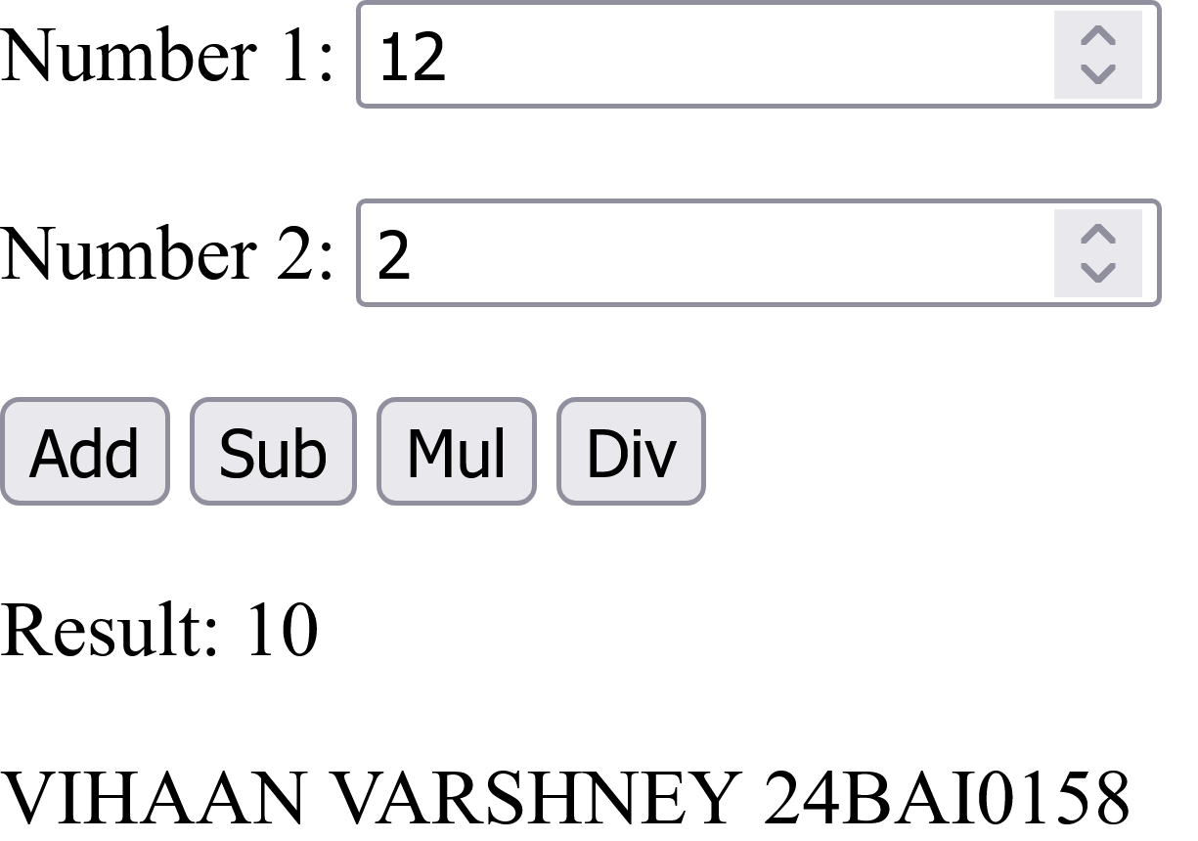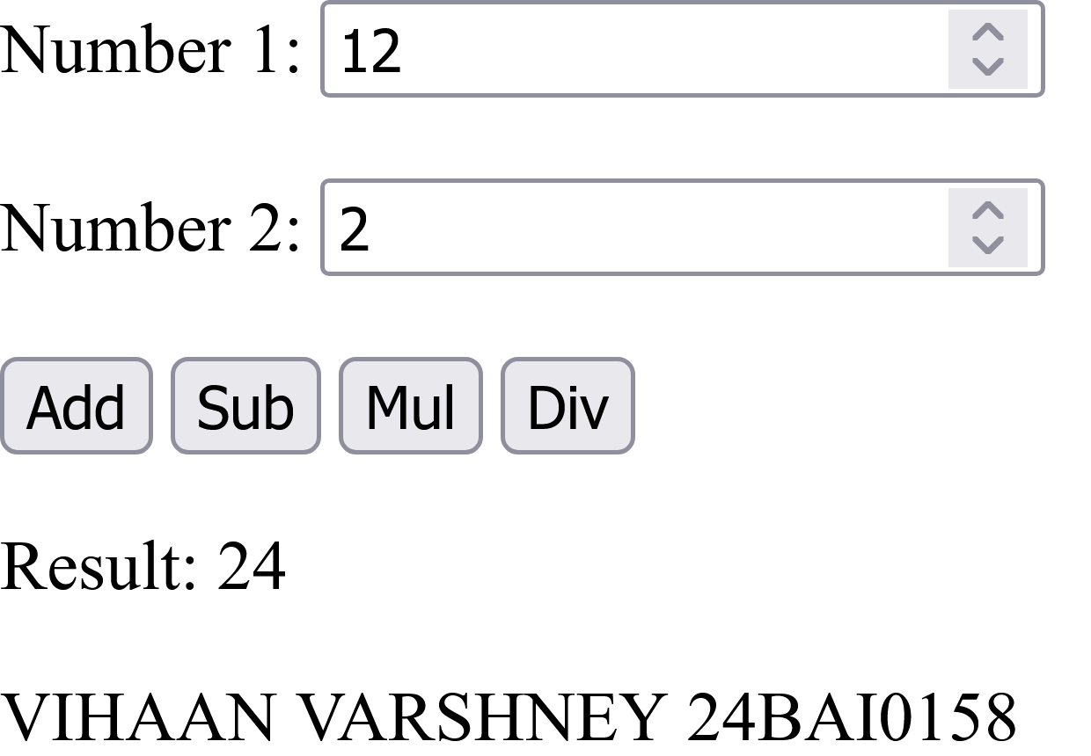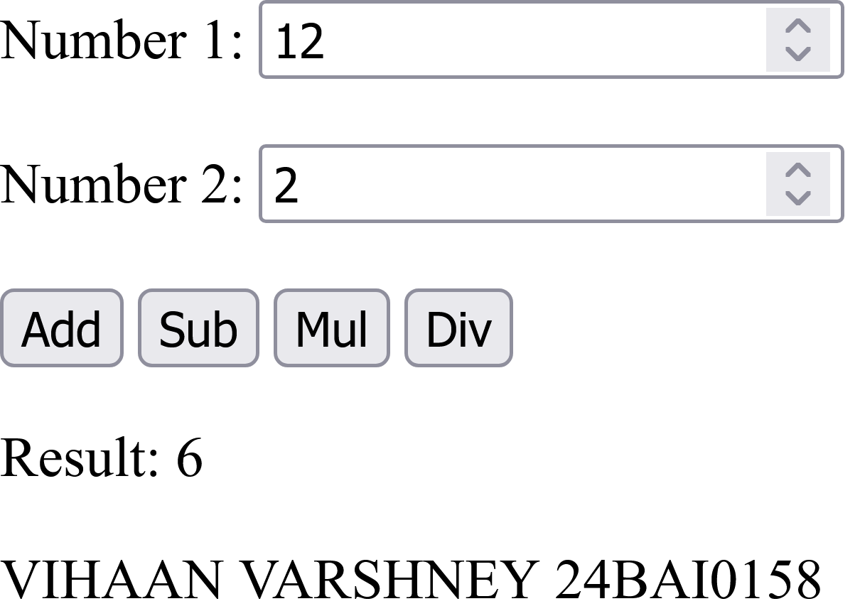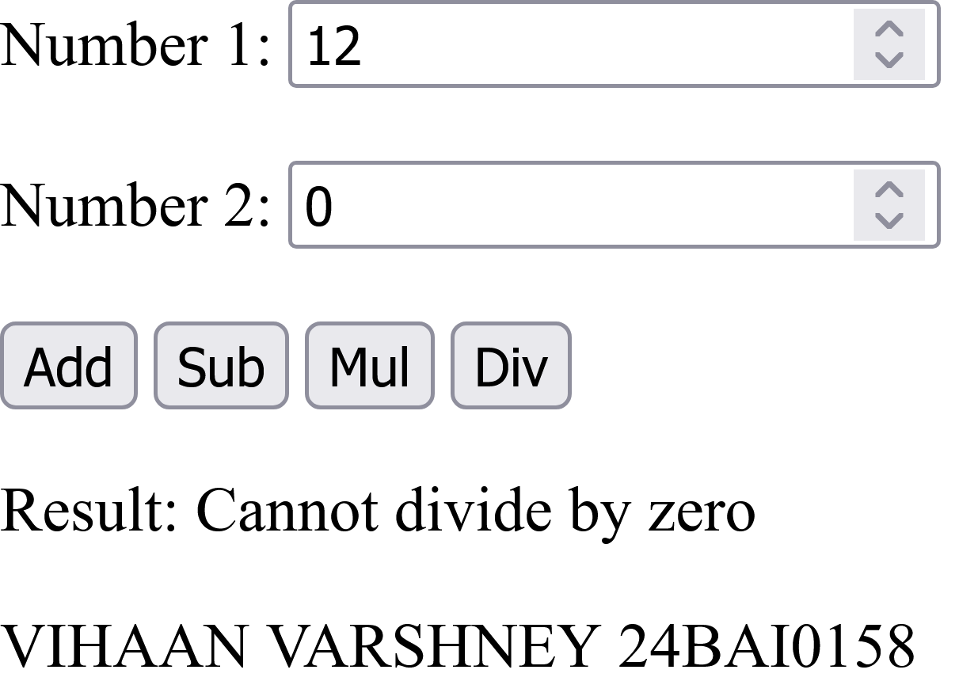
Observations | 1. The program uses `type="number"` input fields to accept numeric values.  2. The `step="any"` attribute allows both integer and decimal inputs.  3. Input values are converted to numbers using `parseFloat()`.  4. A `switch` statement is used to perform addition, subtraction, multiplication, or division.  5. The program includes division by zero handling to prevent invalid calculations.
References

Assessment:  Date: | Problem Statement-6
Create a comprehensive student information system that demonstrates: buttons, functions, variables, identifiers, assignment statements, objects, DOM manipulation, form handling, various controls, and the reset/focus methods.
Concepts:
  - JavaScript objects
  - Object methods (this keyword)
  - Arrays
  - Dynamic table generation
  - Global variables
  - Function parameters
  - CSS styling
List of tags used | List of tags Description  body Defines the document's body, containing all visible content.  br Inserts a single line break.  button Defines a clickable button.  form Defines an HTML form for user input.  h2 Defines a second-level heading.  head Contains meta-information about the HTML page.  html The root element of an HTML page.  input Defines an input control.  option Defines an option in a drop-down list.  p Defines a paragraph.  script Used to embed or reference executable code.  select Defines a drop-down list.  style Used to define style information (CSS).  table Defines an HTML table.  td Defines a standard cell in an HTML table.  th Defines a header cell in an HTML table.  title Specifies a title for the HTML page.  tr Defines a row in an HTML table.
Program | <!DOCTYPE html>  <html>  <head>  <title>Student Information System</title>  <style>  /* Basic CSS styling for the page */  body{  font-family: Arial;  background-color: #f4f4f4;  }  h2{  text-align:center;  }  /* Styling the form */  form{  width:300px;  margin:auto;  padding:15px;  background:white;  border:1px solid #ccc;  }  /* Styling the table */  table{  margin:20px auto;  border-collapse:collapse;  width:70%;  }  th, td{  border:1px solid black;  padding:8px;  text-align:center;  }  th{  background-color:#ddd;  }  button{  margin-top:10px;  }  </style>  <script>  // Global array to store student objects  var students = [];  // Constructor function for Student object  function Student(name, age, course, gender){  // Assignment statements  this.name = name;  this.age = age;  this.course = course;  this.gender = gender;  // Object method using "this"  this.getDetails = function(){  return this.name + " | " + this.age + " | " + this.course + " | " + this.gender;  };  }  // Function to add a student  function addStudent(form){  // Access form elements  var name = form.elements["name"].value;  var age = form.elements["age"].value;  var course = form.elements["course"].value;  var gender = form.elements["gender"].value;  // Create new student object  var studentObj = new Student(name, age, course, gender);  // Add object to array  students.push(studentObj);  // Update table dynamically  displayStudents();  // Reset the form  form.reset();  // Focus back to first field  form.elements["name"].focus();  }  // Function to display students in table  function displayStudents(){  var table = document.getElementById("studentTable");  // Clear previous table rows except header  table.innerHTML =  "<tr><th>Name</th><th>Age</th><th>Course</th><th>Gender</th></tr>";  // Loop through array  for(var i = 0; i < students.length; i++){  var row = "<tr>" +  "<td>" + students[i].name + "</td>" +  "<td>" + students[i].age + "</td>" +  "<td>" + students[i].course + "</td>" +  "<td>" + students[i].gender + "</td>" +  "</tr>";  table.innerHTML += row;  }  }  </script>  </head>  <body>  <h2>Student Information System</h2>  <!-- Student Form -->  <form id="studentForm">  Name:  <input type="text" name="name"><br><br>  Age:  <input type="number" name="age"><br><br>  Course:  <select name="course">  <option value="CSE">CSE</option>  <option value="IT">IT</option>  <option value="ECE">ECE</option>  </select>  <br><br>  Gender:  <input type="radio" name="gender" value="Male">Male  <input type="radio" name="gender" value="Female">Female  <br><br>  <!-- Button controls -->  <button type="button" onclick="addStudent(this.form)">Add Student</button>  <button type="reset">Clear</button>  </form>  <!-- Dynamic table -->  <table id="studentTable">  <tr>  <th>Name</th>  <th>Age</th>  <th>Course</th>  <th>Gender</th>  </tr>  </table>  <p>VIHAAN VARSHNEY 24BAI0158</p>  </body>  </html>
Output Screenshots | 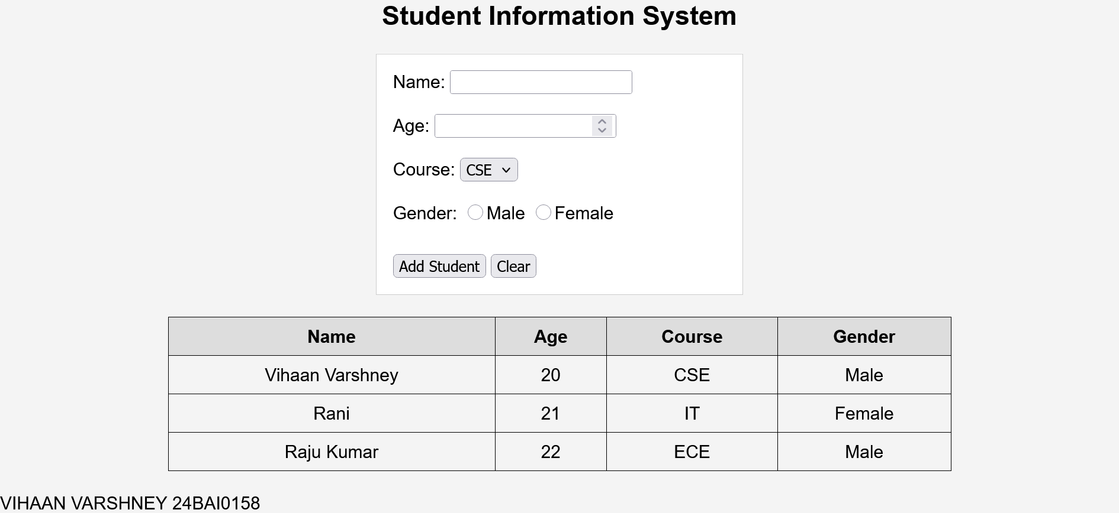
Observations | 1. The program uses a JavaScript object `Student` with properties and a method using the `this` keyword.  2. Student records are stored in a global array `students`.  3. Form elements are accessed using `form.elements` for handling user input.  4. New student objects are created and added to the array using assignment statements.  5. The student table is generated dynamically using DOM manipulation and innerHTML.  6. The program demonstrates different input controls such as text box, number input, select dropdown, and radio buttons.  7. The `reset()` method clears the form and `focus()` sets the cursor back to the first input field.  8. CSS styling is applied to improve the layout of the form and table.
References

Assessment:  Date: | Problem Statement-7
Write a JavaScript program to print numbers from 1 to N using while loop. Take N as input from user.
- Concepts:
  - While loop execution with condition checking
  - Counter initialization and increment
  - Taking user input from text field
  - Displaying output in HTML element

List of tags used | List of tags Description  body Defines the document's body, containing all visible content.  br Inserts a single line break.  h3 Defines a third-level heading.  head Contains meta-information about the HTML page.  html The root element of an HTML page.  input Defines an input control.  p Defines a paragraph.  script Used to embed or reference executable code.  title Specifies a title for the HTML page.
Program | <html>  <head>  <title>print N</title>  <script>  // Function to print numbers from 1 to N  function printNumber(){  // Get the value entered by the user  let n = parseInt(document.getElementById("num1").value);  // Initialize counter variable  let i = 1;  // Variable to store output string  result = "Result: ";  // While loop runs until i becomes greater than N  while(n >= i){  // Append the current number to the result string  result = result + " " + i;  // Increment the counter  i++;  }  // Display the result inside the output paragraph  document.getElementById("output").innerHTML = result;  }  </script>  </head>  <body>  <!-- Heading -->  <h3>Print N numbers</h3>  <!-- Input field to enter number N -->  Number: <input type="number" id="num1" step="any"><br><br>  <!-- Button to trigger the function -->  <input type="button" value="Print Numbers" onclick="printNumber();">  <!-- Area where numbers will be displayed -->  <p id="output"></p>  <p>VIHAAN VARSHNEY 24BAI0158</p>  </body>  </html>
Output Screenshots | 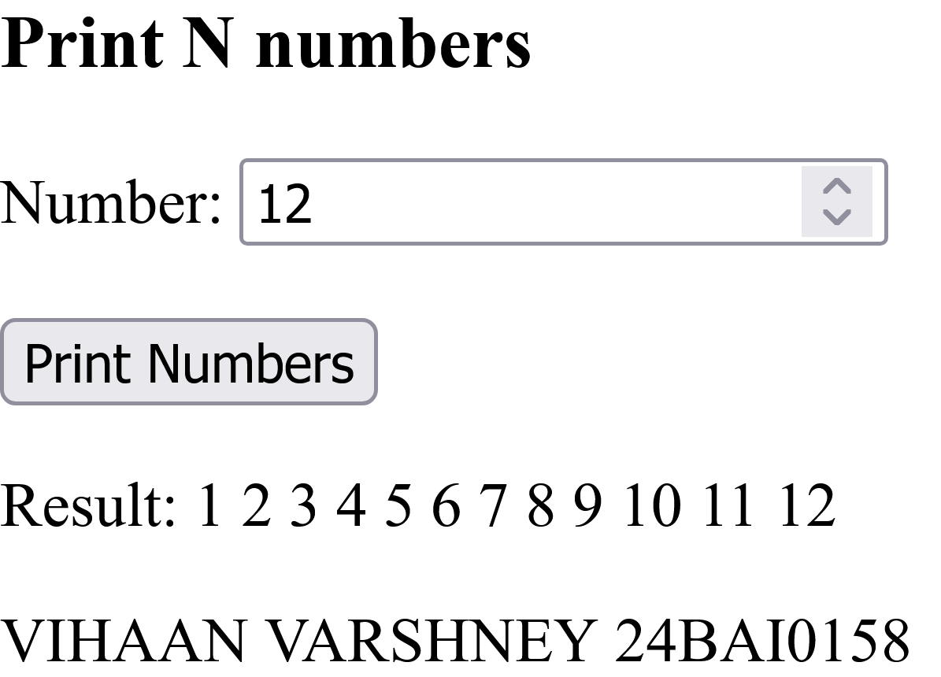
Observations | 1. The program takes user input from an HTML input field using `getElementById()`.  2. A counter variable `i` is initialized to 1 before the loop starts.  3. A `while` loop is used to repeatedly print numbers until the condition `i <= n` bcomes false.  4. The counter variable is incremented inside the loop to avoid an infinite loop.  5. The generated numbers are displayed dynamically on the webpage using `innerHTML`.
References

Assessment:  Date: | Problem Statement-8
Write a JavaScript program to print multiplication table of a number using do-while loop. Take number as input from user.
Concepts:
  - Do-while loop execution (body first, condition later)
  - Minimum one execution guarantee
  - Building string output with HTML line breaks
  - Multiplication operation inside loop

List of tags used | List of tags Description  body Defines the document's body, containing all visible content.  br Inserts a single line break.  h3 Defines a third-level heading.  head Contains meta-information about the HTML page.  html The root element of an HTML page.  input Defines an input control.  p Defines a paragraph.  script Used to embed or reference executable code.  title Specifies a title for the HTML page.
Program | <html>  <head>  <title>Mul Table</title>  <script>  // Function to print multiplication table  function printTable(){  // Get number entered by the user  let n = parseInt(document.getElementById("num1").value);  // Initialize counter variable  let i = 1;  // Variable to store table output  result = "";  // do-while loop executes at least once  do{  // Build multiplication table line  result += n + " X " + i + " = " + (n * i) + "<br>";  // Increment counter  i++;  }while(i <= 10); // Loop condition checked after execution  // Display the table in HTML element  document.getElementById("output").innerHTML = result;  }  </script>  </head>  <body>  <!-- Page heading -->  <h3>Multiplication Table</h3>  <!-- Input field to enter the number -->  Number: <input type="number" id="num1" step="any"><br><br>  <!-- Button to trigger the function -->  <input type="button" value="Print Table" onclick="printTable();">  <!-- Output area -->  <p id="output"></p>  <p>VIHAAN VARSHNEY 24BAI0158</p>  </body>  </html>
Output Screenshots | 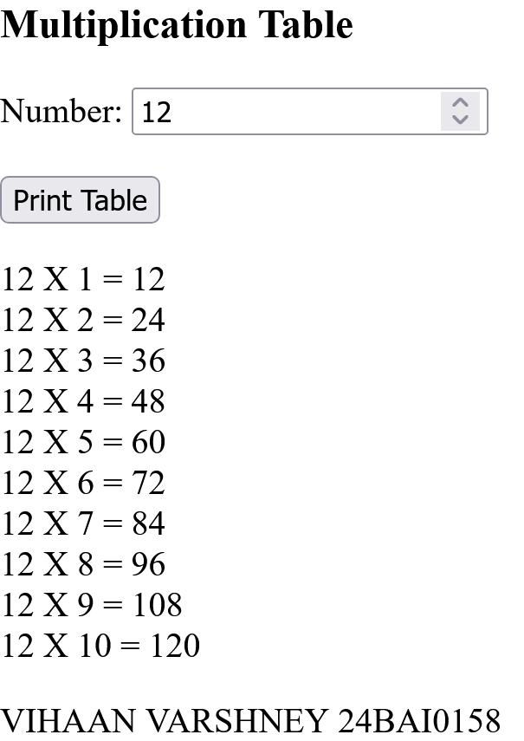
Observations | 1. The program takes a number from the user using an HTML input field.  2. A `do-while` loop is used where the loop body executes before the condition is checked.  3. The loop guarantees at least one execution even if the condition is false initially.  4. Multiplication is performed inside the loop to generate the table values.  5. The output is constructed as a string with `<br>` tags to display each line on a new line in the webpage.
References

Assessment:  Date: | Problem Statement-9
Write a JavaScript program to display selected radio button value. Create three radio buttons for colors (Red, Green, Blue).
Concepts:
  - Radio button grouping using same name attribute
  - Only one selection allowed in a group
  - Accessing collection of elements by name
  - Checking selected state using .checked property
  - Looping through radio button collection

List of tags used | List of tags Description  body Defines the document's body, containing all visible content.  br Inserts a single line break.  h3 Defines a third-level heading.  head Contains meta-information about the HTML page.  html The root element of an HTML page.  input Defines an input control.  p Defines a paragraph.  script Used to embed or reference executable code.  title Specifies a title for the HTML page.
Program | <html>  <head>  <title>Color Button</title>  <script>  // Function to check which radio button is selected  function checkColor(){  // Get all radio buttons with the same name  let buttons = document.getElementsByName("colorButton");  // Variable to store result  let result = "Result: ";  // Loop through the radio button collection  for(let i = 0; i < buttons.length; i++){  // Check if the current radio button is selected  if(buttons[i].checked){  // Append the selected value  result += buttons[i].value;  // Exit the loop once selection is found  break;  }  }  // Display the selected color  document.getElementById("output").innerHTML = result;  }  </script>  </head>  <body>  <!-- Page heading -->  <h3>Color Selected</h3>  <!-- Radio buttons grouped using same name -->  Red: <input type="radio" name="colorButton" value="Red">  Blue: <input type="radio" name="colorButton" value="Blue">  Green: <input type="radio" name="colorButton" value="Green">  <br><br>  <!-- Button to trigger selection check -->  <input type="button" value="Color selected" onclick="checkColor()">  <!-- Output area -->  <p id="output"></p>  <p>VIHAAN VARSHNEY 24BAI0158</p>  </body>  </html>
Output Screenshots | 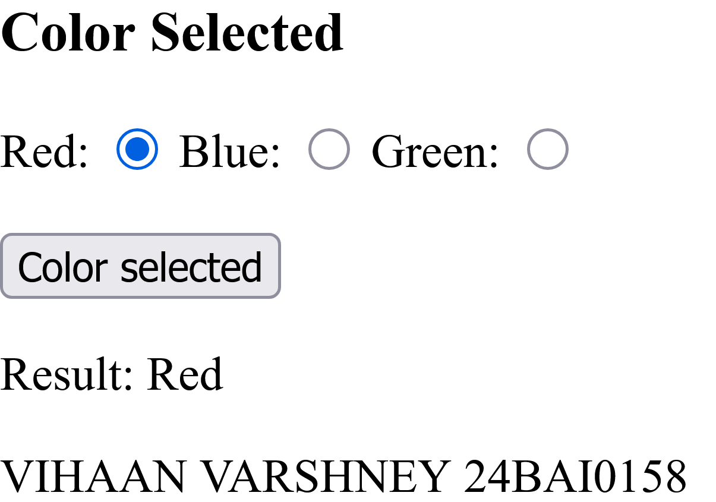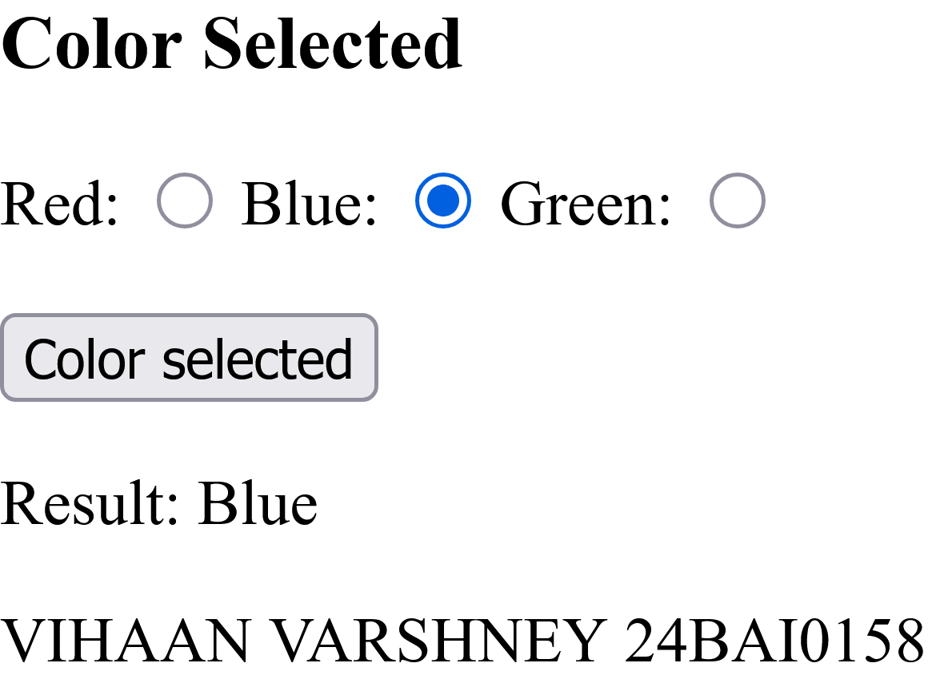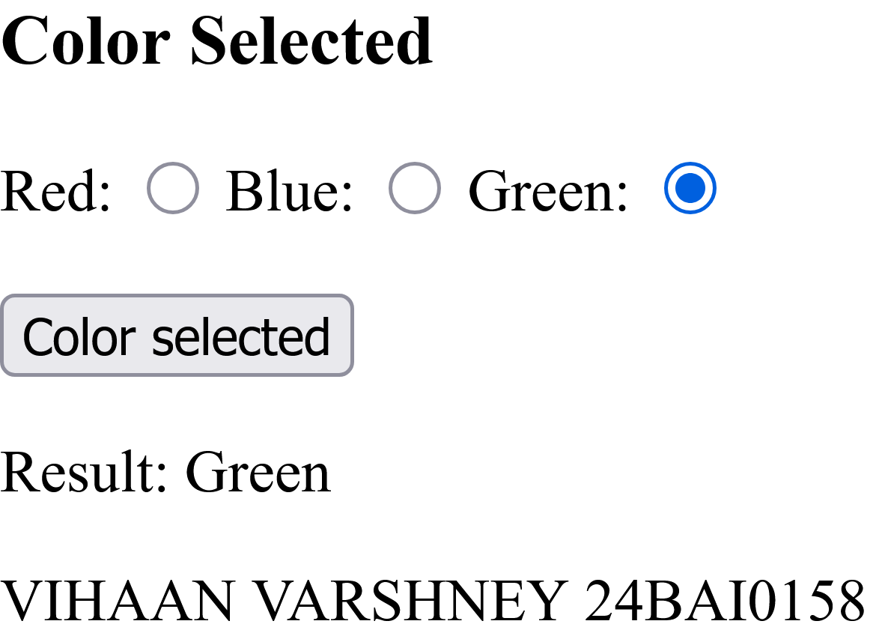
Observations | 1. Radio buttons are grouped using the same `name` attribute so that only one option can be selected at a time.  2. The program accesses all radio buttons using `document.getElementsByName()`.  3. A loop is used to iterate through the radio button collection.  4. The `.checked` property is used to identify the selected radio button.  5. The selected color value is displayed dynamically using `innerHTML`.
References

Assessment:  Date: | Problem Statement-10
Write a JavaScript program to count and display how many checkboxes are selected. Create four checkboxes for subjects.
Concepts:
  - Multiple selections allowed in checkboxes
  - Building array of selected values
  - Using push() to add elements to array
  - Using join() to convert array to string
  - Counter variable for counting selections

List of tags used | List of tags Description  body Defines the document's body, containing all visible content.  br Inserts a single line break.  h3 Defines a third-level heading.  head Contains meta-information about the HTML page.  html The root element of an HTML page.  input Defines an input control.  p Defines a paragraph.  script Used to embed or reference executable code.  title Specifies a title for the HTML page.
Program | <html>  <head>  <title>Subject Selection</title>  <script>  // Function to count and display selected subjects  function checkColor(){  // Get all checkbox elements by name  let buttons = document.getElementsByName("colorButton");  // Variable to store final output string  let result = "";  // Array to store selected subject names  let selected = [];  // Counter variable to count selected checkboxes  let selectedCount = 0;  // Loop through all checkbox elements  for(let i = 0; i < buttons.length; i++){  // Check if the checkbox is selected  if(buttons[i].checked){  // Add selected subject to array  selected.push(buttons[i].value);  // Increase counter  selectedCount++;  }  }  // Convert array to string using join()  result = result + selected.join(", ");  // Display count and selected subjects  document.getElementById("output").innerHTML =  "Selected " + selectedCount + " subjects : " + result;  }  </script>  </head>  <body>  <!-- Page heading -->  <h3>Subject Selected</h3>  <!-- Checkboxes for subjects (multiple selections allowed) -->  Maths: <input type="checkbox" name="colorButton" value="Maths"><br>  Physics: <input type="checkbox" name="colorButton" value="Physics"><br>  Chemistry: <input type="checkbox" name="colorButton" value="Chemistry"><br>  English: <input type="checkbox" name="colorButton" value="English"><br>  <!-- Button to trigger selection check -->  <input type="button" value="Color selected" onclick="checkColor()">  <!-- Output area -->  <p id="output"></p>  <p>VIHAAN VARSHNEY 24BAI0158</p>  </body>  </html>
Output Screenshots | 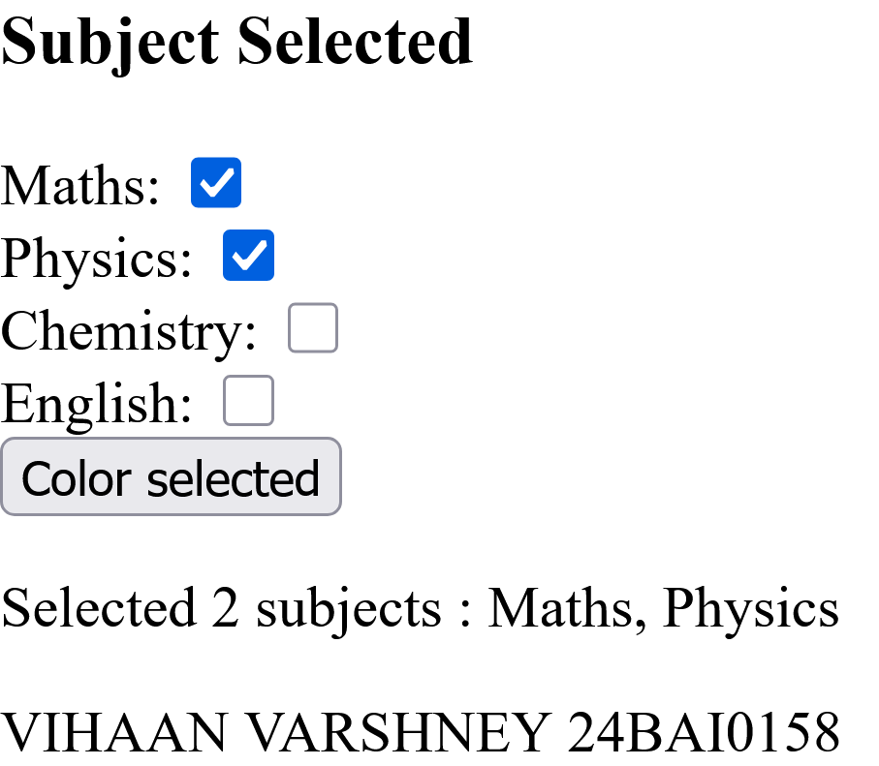
Observations | 1. Checkboxes allow multiple selections unlike radio buttons.  2. The program accesses checkbox elements using `document.getElementsByName()`.  3. Selected checkbox values are stored in an array using the `push()` method.  4. The `join()` function converts the array into a comma-separated string.  5. A counter variable is used to count how many checkboxes are selected.
References

Assessment:  Date: | Problem Statement-11
Write a JavaScript program to calculate simple interest using external JS file. Take principal, rate, and time as input from user.
Concepts:
  - External JavaScript file linking
  - Mathematical calculation in external function
  - Multiple input parameters handling
  - Returning calculated result
  - Formula implementation: SI = (P × R × T) / 100

List of tags used | List of tags Description  body Defines the document's body, containing all visible content.  br Inserts a single line break.  button Defines a clickable button.  h1 Defines the most important heading.  head Contains meta-information about the HTML page.  html The root element of an HTML page.  input Defines an input control.  label Defines a label for an <input> element.  meta Defines metadata about an HTML document.  p Defines a paragraph.  script Used to embed or reference executable code.  title Specifies a title for the HTML page.
Program | index.html  <!DOCTYPE html>  <html lang="en">  <head>  <meta charset="UTF-8">  <title>Simple Interest</title>  </head>  <body>  <!-- Page heading -->  <h1>Simple Interest Calculator</h1>  <!-- Input field for Principal amount -->  <label>Principal</label>  <input id="principle" type="number"><br>  <!-- Input field for Rate -->  <label>Rate</label>  <input id="rate" type="number"><br>  <!-- Input field for Time -->  <label>Time</label>  <input id="time" type="number"><br><br>  <!-- Button to calculate simple interest -->  <button onclick="simpleInterest();">  Calculate Simple Interest  </button>  <!-- Area to display result -->  <p id="output"></p>  <!-- Linking external JavaScript file -->  <script src="script.js"></script>  <p>VIHAAN VARSHNEY 24BAI0158</p>  </body>  </html>  script.js  // Function to calculate simple interest  function simpleInterest(){  // Get input values from HTML fields  let p = document.getElementById("principle").value;  let r = document.getElementById("rate").value;  let t = document.getElementById("time").value;  // Variable to store simple interest  let si;  // Simple Interest formula  // SI = (P × R × T) / 100  si = (p * r * t) / 100;  // Display the calculated result on the webpage  document.getElementById("output").innerHTML =  "Simple Interest: " + si;  }
Output Screenshots | 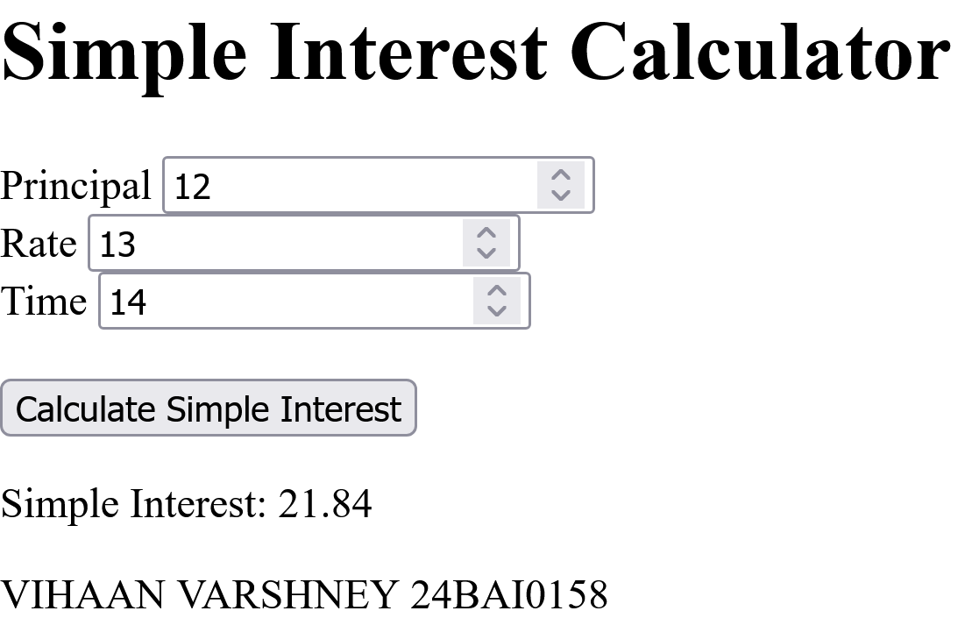
Observations | 1. The program links an external JavaScript file using the `<script src="script.js">` tag.  2. User inputs for principal, rate, and time are taken using HTML number input fields.  3. The simple interest formula `SI = (P × R × T) / 100` is implemented in the JavaScript function.  4. Multiple input values are retrieved using `document.getElementById()`.  5. The calculated result is displayed dynamically using `innerHTML`.
References

Assessment:  Date: | Problem Statement-12
Create a job skills form with multiple checkboxes. Use a for loop to validate that at least 3 skills are selected. Display the selected skills or an error message.
Concepts:
  - for loop with index
  - Checkbox validation
  - checkValidity() method
  - Array length property
  - String concatenation
List of tags used | List of tags Description  body Defines the document's body.  br Inserts a single line break.  button Defines a clickable button.  form Defines an HTML form.  h1 Defines the main heading.  head Contains meta-information.  html The root element.  input Defines an input control.  label Defines a label for an input.  meta Defines metadata.  p Defines a paragraph.  script Used to embed executable code.  title Specifies a title.
Program | <!DOCTYPE html>  <html lang="en">  <head>  <meta charset="UTF-8">  <title>Skill Selection</title>  <script>  // Function to validate selected skills  function checkTheValidity() {  // Get the form element  let form = document.getElementById("skillForm");  // Use HTML5 form validation  if (!form.checkValidity()) {  document.getElementById("output").innerHTML =  "Please select at least one skill.";  return;  }  // Get all checkbox elements with name "skills"  let skillsSelected = document.getElementsByName("skills");  // Array to store selected skills  let skillsList = [];  // Loop through all checkboxes  for (let i = 0; i < skillsSelected.length; i++) {  // Check if checkbox is selected  if (skillsSelected[i].checked) {  // Add selected skill to array  skillsList.push(skillsSelected[i].value);  }  }  // Check if at least 3 skills are selected  if (skillsList.length >= 3) {  // Display selected skills  document.getElementById("output").innerHTML =  "Selected Skills: " + skillsList.join(", ");  } else {  // Display error message  document.getElementById("output").innerHTML =  "Error: Select at least 3 skills.";  }  }  </script>  </head>  <body>  <h1>Skill Check</h1>  <!-- Skill selection form -->  <form id="skillForm">  <!-- Multiple checkbox options -->  <label><input type="checkbox" name="skills" value="HTML" required> HTML</label><br>  <label><input type="checkbox" name="skills" value="CSS"> CSS</label><br>  <label><input type="checkbox" name="skills" value="JS"> JS</label><br>  <label><input type="checkbox" name="skills" value="Python"> Python</label><br>  <label><input type="checkbox" name="skills" value="C#"> C#</label><br>  <label><input type="checkbox" name="skills" value="R"> R</label><br><br>  <!-- Button to validate skills -->  <button type="button" onclick="checkTheValidity()">Check</button>  </form>  <!-- Output display -->  <p id="output"></p>  <p>VIHAAN VARSHNEY 24BAI0158</p>  </body>  </html>
Output Screenshots | 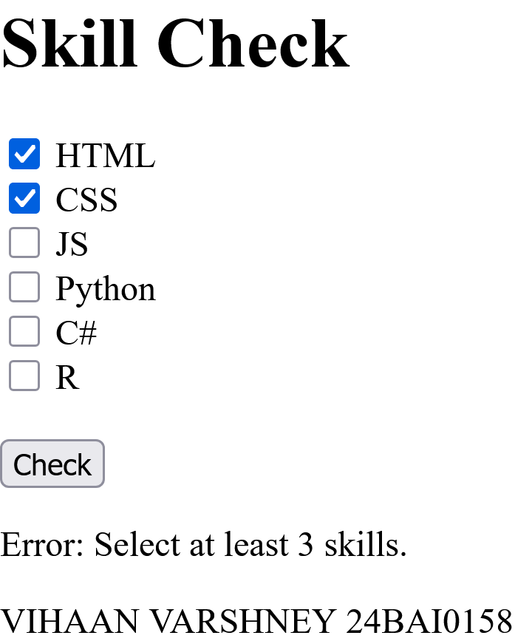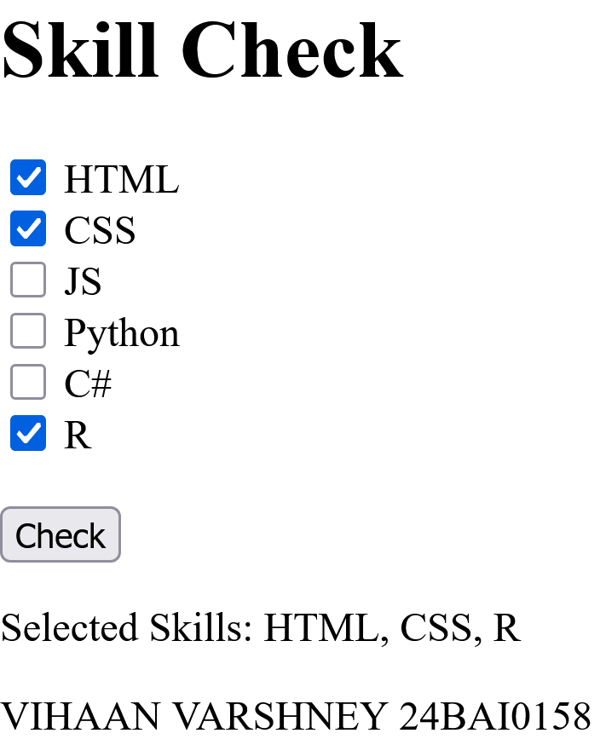
Observations | 1. The program uses multiple checkboxes to allow selection of several skills.  2. A `for` loop is used to iterate through all checkbox
References

Assessment:  Date: | Problem Statement-13
Create a product order form with multiple fieldsets. Use the modern for...of loop to calculate total price based on selected items from different categories.
Concepts:
  - for...of loop (modern JavaScript)
  - Multiple fieldsets
  - Dynamic calculation
  - parseFloat() for price conversion
List of tags used | List of tags Description  body Defines the document's body.  br Inserts a single line break.  button Defines a clickable button.  fieldset Groups related elements in a form.  form Defines an HTML form.  h1 Defines the main heading.  head Contains meta-information.  html The root element.  input Defines an input control.  label Defines a label for an input.  legend Defines a caption for a <fieldset>.  meta Defines metadata.  p Defines a paragraph.  script Used to embed executable code.  title Specifies a title.
Program | <!DOCTYPE html>  <html lang="en">  <head>  <meta charset="UTF-8">  <title>Order Form</title>  <script>  // Function to calculate total price of selected products  function calValue() {  // Get all product checkboxes  let prods = document.getElementsByName("product");  // Variable to store total value  let value = 0;  // Modern for...of loop to iterate through checkbox collection  for(let item of prods){  // Check if the checkbox is selected  if(item.checked){  // Convert price string to number using parseFloat  value += parseFloat(item.value);  }  }  // Display the calculated total price  document.getElementById("output").innerHTML =  "Total Value: " + value;  }  </script>  </head>  <body>  <h1>Product Order Form</h1>  <form id="groceryForm">  <!-- First category -->  <fieldset>  <legend>Fruits</legend>  <label>  <input type="checkbox" name="product" value="12.99">  Apple (12.99)  </label><br>  <label>  <input type="checkbox" name="product" value="11.99">  Orange (11.99)  </label><br>  <label>  <input type="checkbox" name="product" value="10.99">  Bananas (10.99)  </label><br>  </fieldset>  <!-- Second category -->  <fieldset>  <legend>Dairy</legend>  <label>  <input type="checkbox" name="product" value="13.99">  Milk (13.99)  </label><br>  <label>  <input type="checkbox" name="product" value="14.99">  Curd (14.99)  </label><br>  <label>  <input type="checkbox" name="product" value="15.99">  Cheese (15.99)  </label><br>  </fieldset>  <!-- Third category -->  <fieldset>  <legend>Pantry Staples</legend>  <label>  <input type="checkbox" name="product" value="9.99">  Rice (9.99)  </label><br>  <label>  <input type="checkbox" name="product" value="8.99">  Pulses (8.99)  </label><br>  <label>  <input type="checkbox" name="product" value="7.99">  Flour (7.99)  </label><br>  </fieldset>  <br>  <!-- Button to calculate total -->  <button type="button" onclick="calValue();">  Calculate  </button>  <!-- Output area -->  <p id="output"></p>  </form>  <p>VIHAAN VARSHNEY 24BAI0158</p>  </body>  </html>
Output Screenshots | 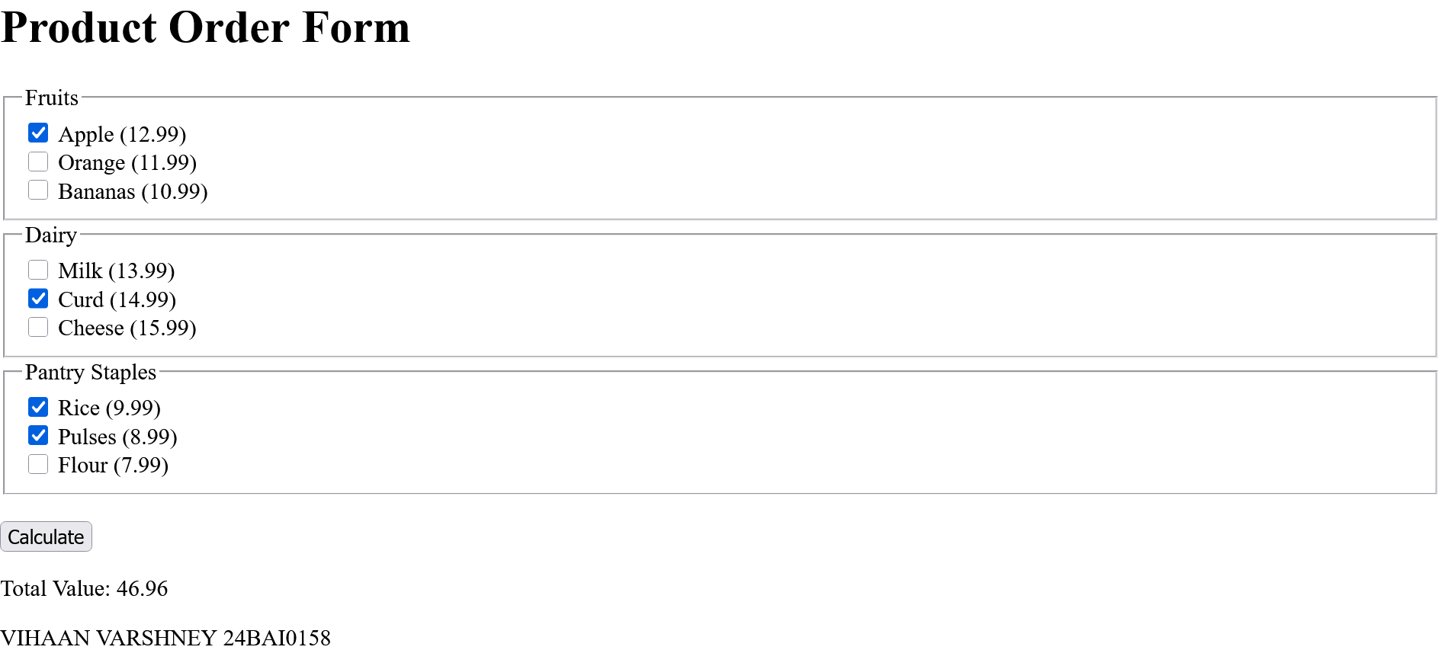
Observations | 1. The form uses multiple `fieldset` elements to group products into categories.  2. The modern `for...of` loop is used to iterate through the checkbox collection.  3. The `parseFloat()` function converts price values from strings to numeric values.  4. The total price is calculated dynamically based on selected items.  5. The final calculated value is displayed on the webpage using `innerHTML`.
References

Assessment:  Date: | Problem Statement-14
Create a text styling application. Use buttons to apply predefined CSS classes (italic, bold, small-caps) to a message using the className property.
Concepts:
  - className property
  - Predefined CSS classes
  - Multiple class assignment
  - fieldset and legend for grouping.
List of tags used | List of tags Description  body Defines the document's body.  fieldset Groups related elements in a form.  form Defines an HTML form.  h1 Defines the main heading.  head Contains meta-information.  html The root element.  input Defines an input control.  legend Defines a caption for a <fieldset>.  meta Defines metadata.  p Defines a paragraph.  script Used to embed executable code.  style Used to define style information (CSS).  title Specifies a title.
Program | <!DOCTYPE html>  <html lang="en">  <head>  <meta charset="UTF-8">  <title>CSS Property</title>  <style>  /* CSS class for bold text */  .boldText {  font-weight: bold;  }  /* CSS class for italic text */  .italicText {  font-style: italic;  }  /* CSS class for small-caps text */  .smallCapsText {  font-variant: small-caps;  }  </style>  <script>  // Apply bold style  function boldStyle(){  let message = document.getElementById("output");  message.className = "boldText";  }  // Apply italic style  function italicStyle(){  let message = document.getElementById("output");  message.className = "italicText";  }  // Apply small caps style  function smallCapStyle(){  let message = document.getElementById("output");  message.className = "smallCapsText";  }  // Apply multiple styles together  function allStyle(){  let message = document.getElementById("output");  // Assign multiple CSS classes at once  message.className = "boldText italicText smallCapsText";  }  // Clear all styles  function clearStyle(){  let message = document.getElementById("output");  // Remove all CSS classes  message.className = "";  }  </script>  </head>  <body>  <h1>CSS Property</h1>  <form id="styleForm">  <!-- Fieldset for individual styles -->  <fieldset>  <legend>Text Style</legend>  <input type="button" value="Bold" onclick="boldStyle();">  <input type="button" value="Italic" onclick="italicStyle();">  <input type="button" value="Small-Caps" onclick="smallCapStyle();">  </fieldset>  <!-- Fieldset for combined styles -->  <fieldset>  <legend>Multiple-Styles</legend>  <input type="button" value="Apply-All" onclick="allStyle();">  <input type="button" value="Clear" onclick="clearStyle();">  </fieldset>  <!-- Text that will be styled -->  <p id="output">  This is a sample message to demonstrate text styling.  </p>  </form>  <p>VIHAAN VARSHNEY 24BAI0158</p>  </body>  </html>
Output Screenshots | 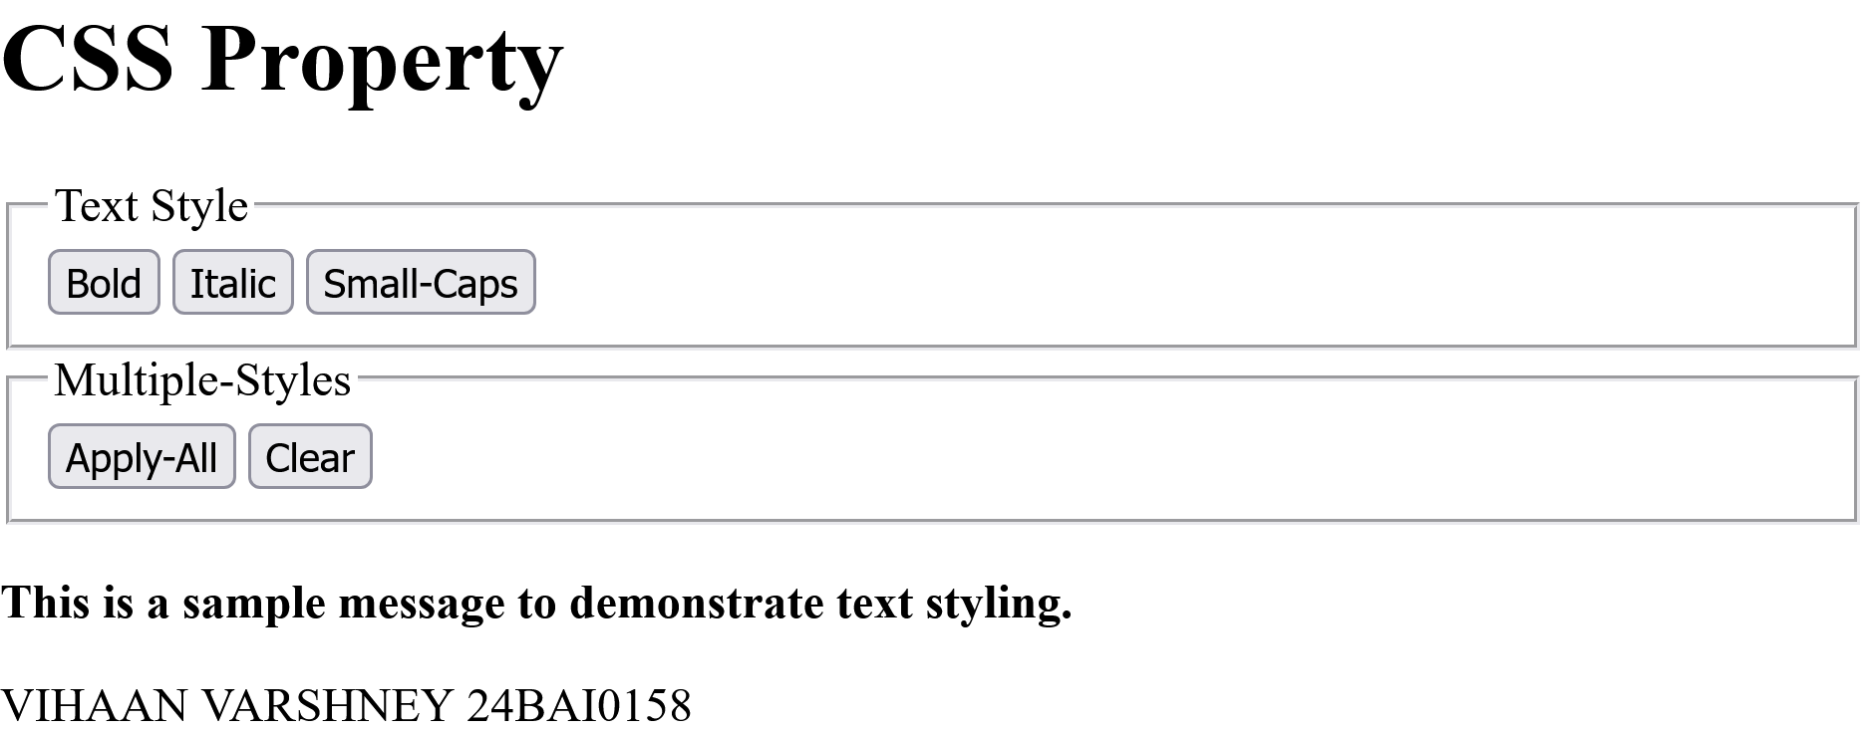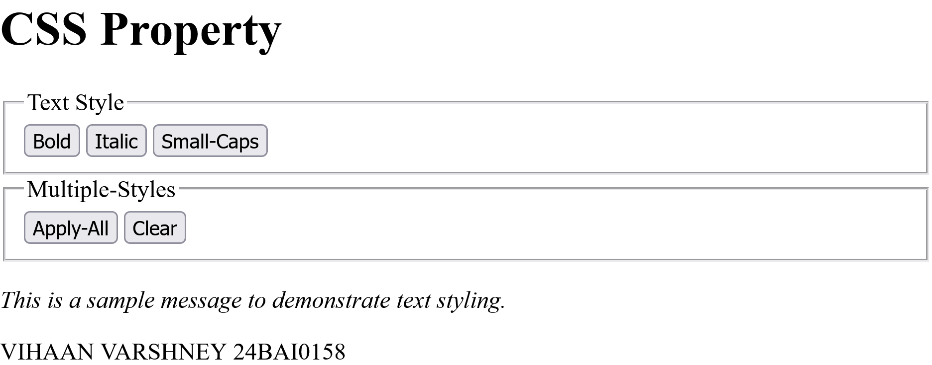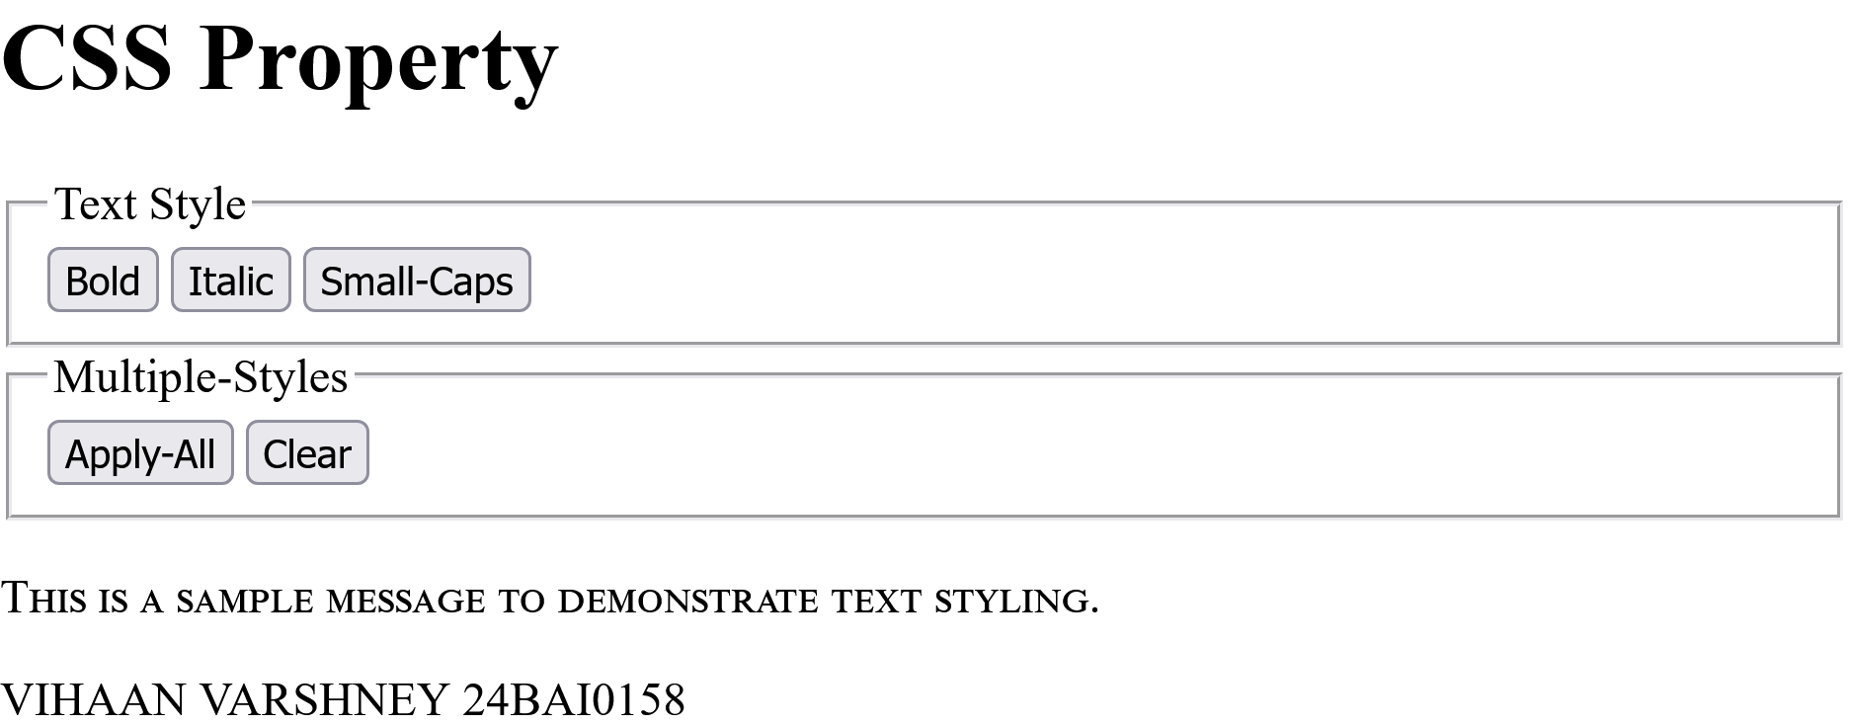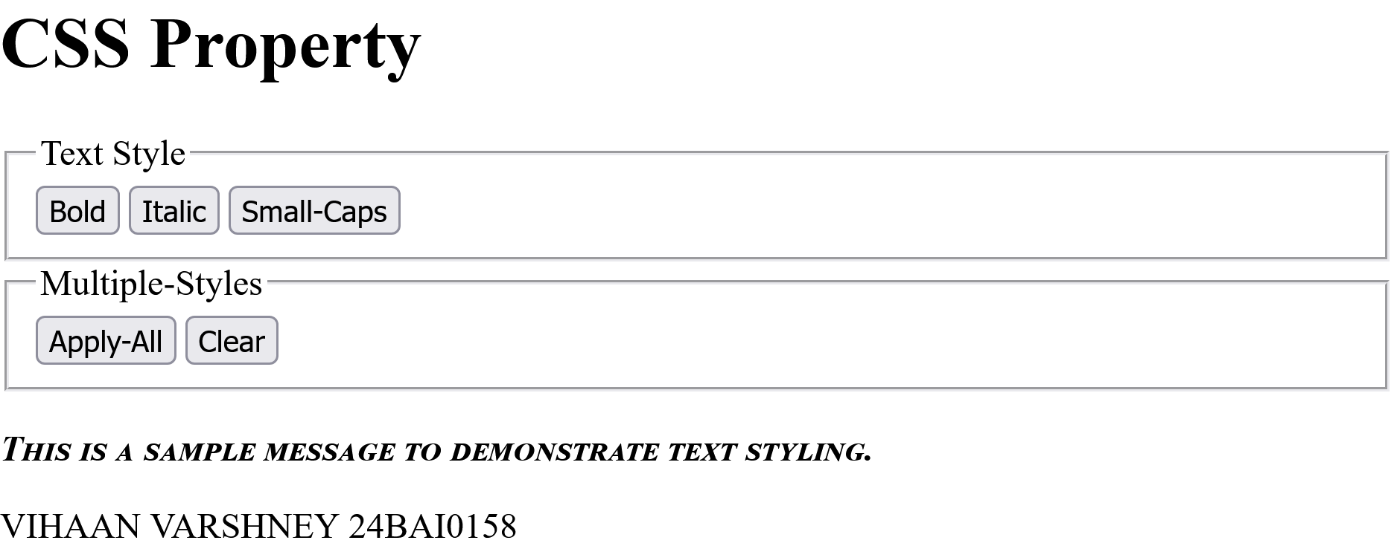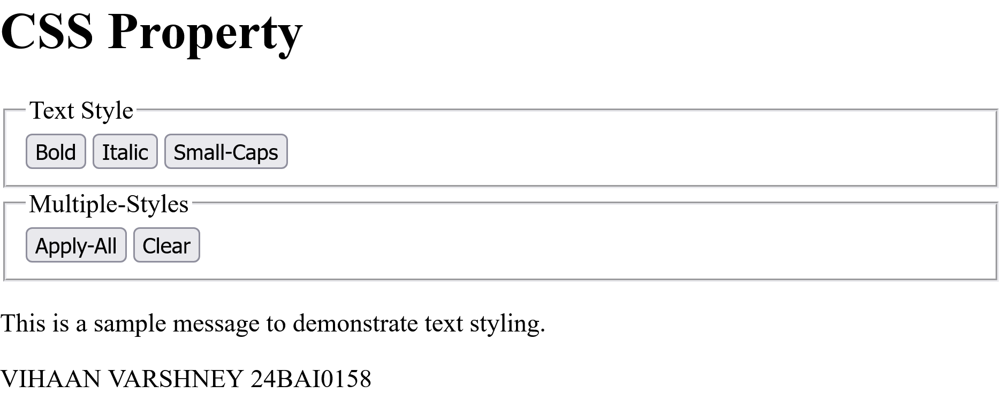
Observations | 1. The program uses predefined CSS classes to define different text styles.  2. The `className` property is used to dynamically apply styles to the message element.  3. Multiple CSS classes can be applied at once by assigning space-separated class names.  4. The interface uses `fieldset` and `legend` elements to logically group styling controls.  5. JavaScript functions are triggered by button clicks to update the text styling dynamically.
References

Assessment:  Date: | Problem Statement-15
Create a dynamic font customization tool. Use the style property to directly modify CSS properties (fontSize, color, backgroundColor) based on user input.
Concepts:
  - style property for inline CSS
  - Dynamic property changes
  - fieldset grouping
  - Color picker input
  - Range slider input
List of tags used | List of tags Description  body Defines the document's body.  div Defines a division or section.  fieldset Groups related elements in a form.  form Defines an HTML form.  h1 Defines the main heading.  head Contains meta-information.  html The root element.  input Defines an input control.  legend Defines a caption for a <fieldset>.  meta Defines metadata.  p Defines a paragraph.  script Used to embed executable code.  style Used to define style information.  title Specifies a title.
Program | <!DOCTYPE html>  <html lang="en">  <head>  <meta charset="UTF-8">  <title>Dynamic Font Customization Tool</title>  <style>  /* Basic page styling */  body {  font-family: Arial, sans-serif;  }  /* Preview area where styles will be applied */  #previewArea {  padding: 20px;  margin-top: 20px;  border: 1px solid #ccc;  /* Default font size and background */  font-size: 16px;  background-color: #ffffff;  }  /* Spacing between fieldsets */  fieldset {  margin-bottom: 15px;  }  </style>  <script>  // Variable to store preview area element  let previewArea;  // Run script after page loads  window.onload = function() {  // Get preview text area  previewArea = document.getElementById("previewArea");  // Get input controls  const fontSizeSlider = document.getElementById("fontSize");  const fontColorPicker = document.getElementById("fontColor");  const bgColorPicker = document.getElementById("bgColor");  // Change font size dynamically  fontSizeSlider.addEventListener("input", function() {  // Modify CSS using style property  previewArea.style.fontSize = this.value + "px";  });  // Change text color dynamically  fontColorPicker.addEventListener("input", function() {  previewArea.style.color = this.value;  });  // Change background color dynamically  bgColorPicker.addEventListener("input", function() {  previewArea.style.backgroundColor = this.value;  });  };  </script>  </head>  <body>  <h1>Dynamic Font Customization Tool</h1>  <form id="styleForm">  <!-- Font size control -->  <fieldset>  <legend>Change Font Size</legend>  <!-- Range slider input -->  <input type="range" id="fontSize" min="10" max="72" value="16">  </fieldset>  <!-- Font color control -->  <fieldset>  <legend>Font Color</legend>  <!-- Color picker input -->  <input type="color" id="fontColor" value="#000000">  </fieldset>  <!-- Background color control -->  <fieldset>  <legend>Background Color</legend>  <!-- Color picker input -->  <input type="color" id="bgColor" value="#ffffff">  </fieldset>  </form>  <!-- Text preview area -->  <div id="previewArea">  This is a live preview text.  Adjust the controls above to customize the font size, text color,  and background color dynamically.  </div>  <p>VIHAAN VARSHNEY 24BAI0158</p>  </body>  </html>
Output Screenshots | 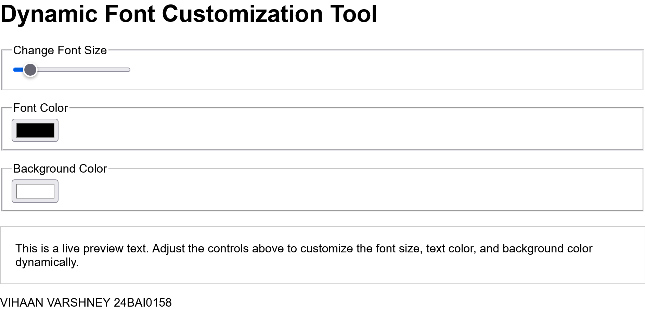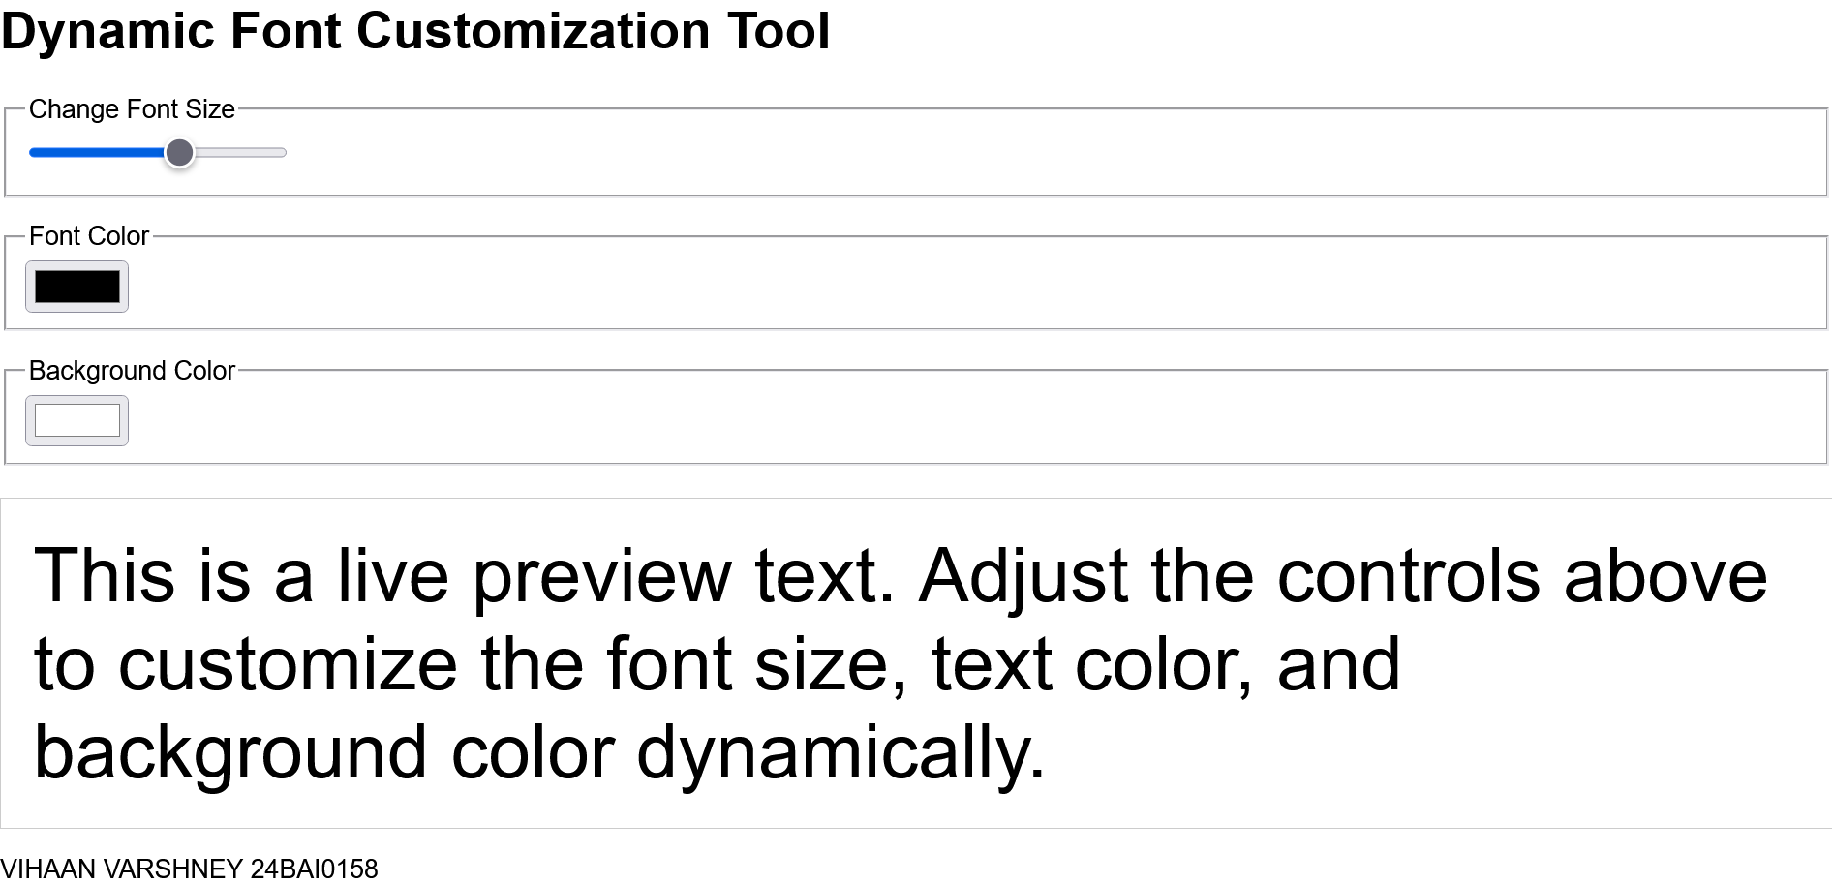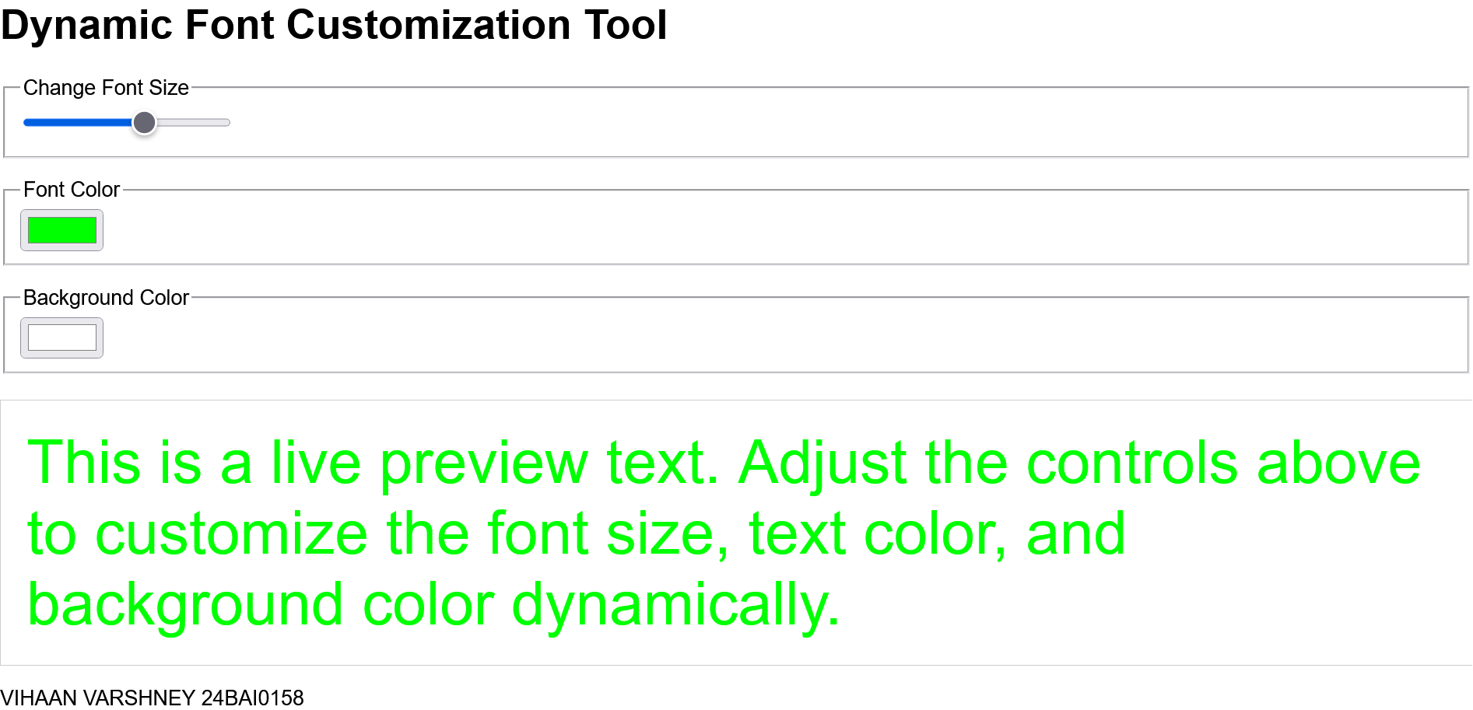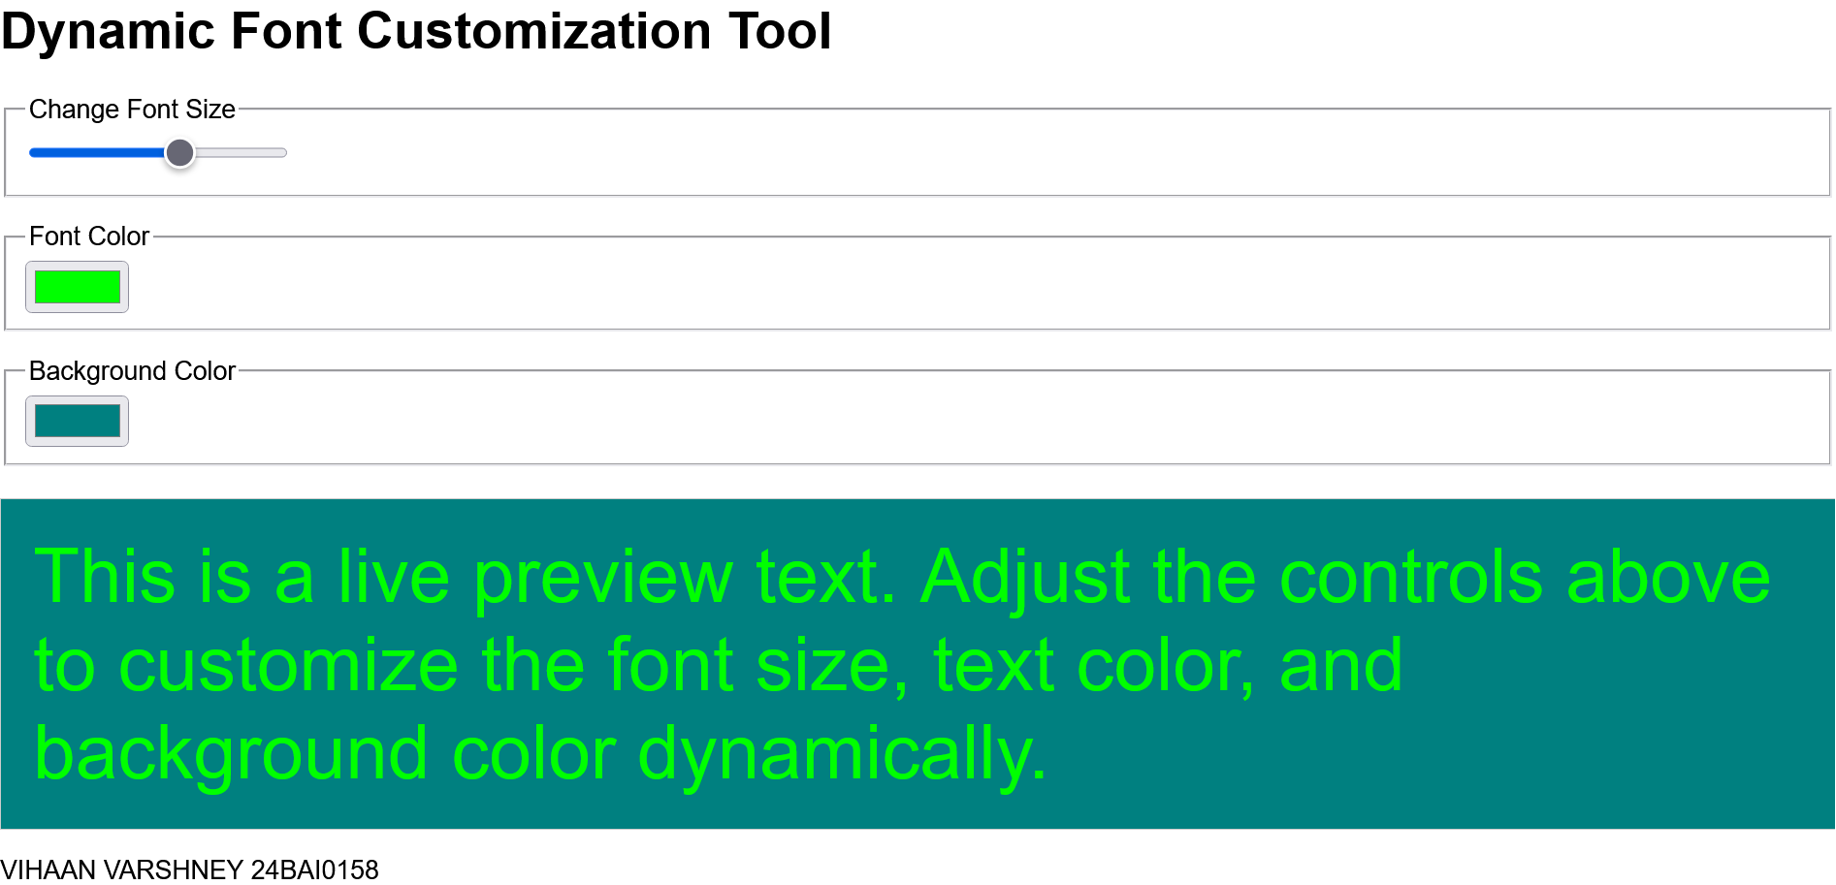
Observations | 1. The program uses the `style` property to dynamically modify inline CSS properties.  2. The font size is adjusted using a range slider input.  3. Color picker inputs allow the user to select text and background colors.  4. Event listeners detect user input and update the preview text in real time.  5. Fieldsets and legends are used to organize different styling controls.
References

Assessment:  Date: | Problem Statement-16
Create an overlapping image gallery where clicking an image brings it to the front by dynamically modifying its z-index using JavaScript.
Concepts:
  - z-index CSS property
  - position: absolute
  - Global variable for tracking top index
  - ++ increment operator (prefix mode)
List of tags used | List of tags Description  body Defines the document's body.  div Defines a division or section.  h2 Defines a second-level heading.  head Contains meta-information.  html The root element.  img Defines an image.  meta Defines metadata.  p Defines a paragraph.  script Used to embed executable code.  style Used to define style information.  title Specifies a title.
Program | <!DOCTYPE html>  <html lang="en">  <head>  <meta charset="UTF-8">  <title>Overlapping Image Gallery</title>  <style>  /* Page styling */  body {  font-family: Arial, sans-serif;  text-align: center;  }  /* Gallery container */  .gallery {  position: relative; /* Parent reference for absolute elements */  width: 600px;  height: 400px;  margin: 40px auto;  border: 2px solid #333;  }  /* Image styling */  .gallery img {  position: absolute; /* Allows images to overlap */  width: 200px;  height: 150px;  cursor: pointer;  /* Smooth scaling animation */  transition: transform 0.3s;  }  /* Slight zoom effect on hover */  .gallery img:hover {  transform: scale(1.05);  }  /* Initial overlapping positions with different z-index values */  #img1 { top: 20px; left: 30px; z-index: 1; }  #img2 { top: 80px; left: 120px; z-index: 2; }  #img3 { top: 140px; left: 210px; z-index: 3; }  #img4 { top: 200px; left: 300px; z-index: 4; }  </style>  <script>  // Global variable to track the highest z-index value  let topIndex = 4;  // Function to bring the clicked image to the front  function bringToFront(element) {  // Increase the topIndex using prefix increment operator  // Assign the new z-index to the clicked image  element.style.zIndex = ++topIndex;  }  </script>  </head>  <body>  <h2>Overlapping Image Gallery</h2>  <p>Click any image to bring it to the front</p>  <div class="gallery">  <!-- Each image calls the function when clicked -->  <img id="img1"  src="https://picsum.photos/id/1015/200/150"  onclick="bringToFront(this)">  <img id="img2"  src="https://picsum.photos/id/1025/200/150"  onclick="bringToFront(this)">  <img id="img3"  src="https://picsum.photos/id/1035/200/150"  onclick="bringToFront(this)">  <img id="img4"  src="https://picsum.photos/id/1045/200/150"  onclick="bringToFront(this)">  </div>  <p>VIHAAN VARSHNEY 24BAI0158</p>  </body>  </html>
Output Screenshots | 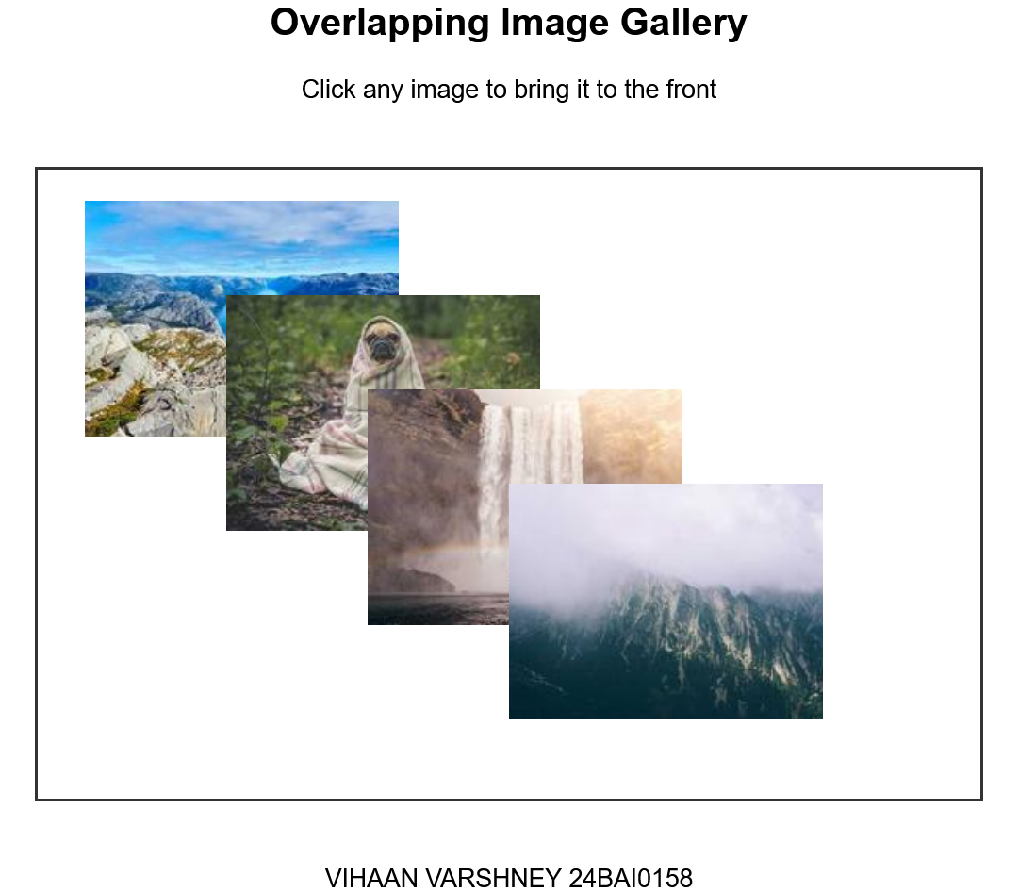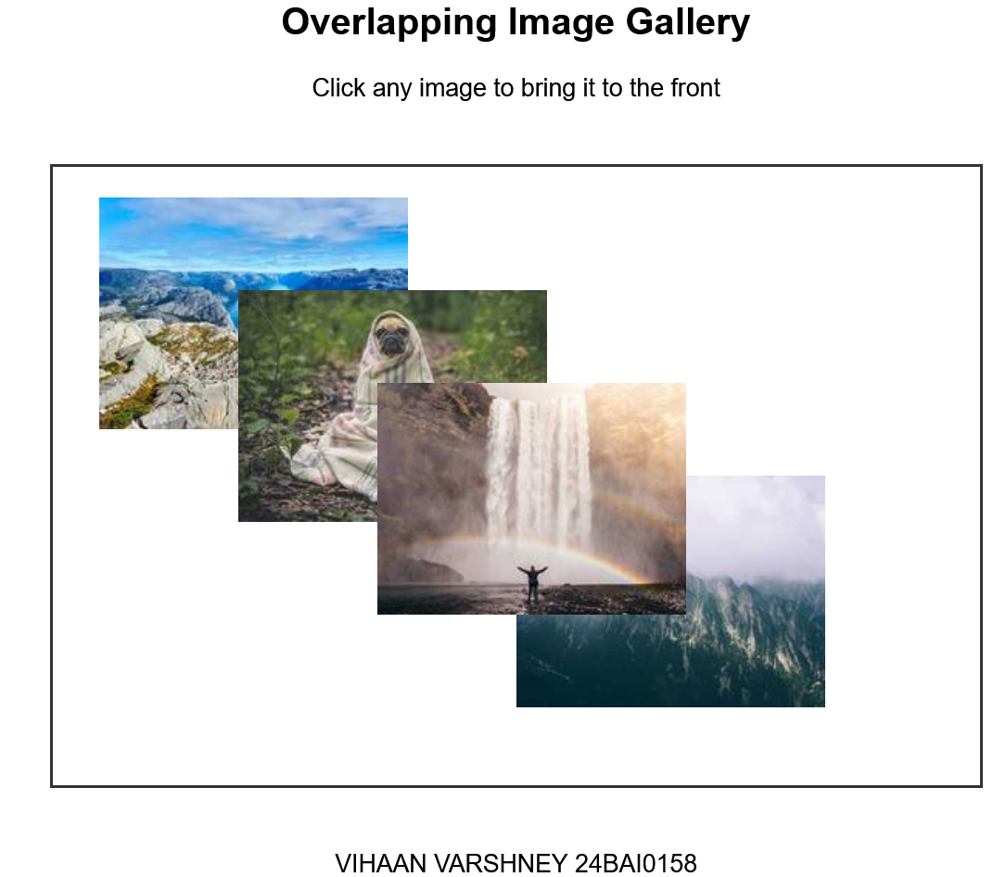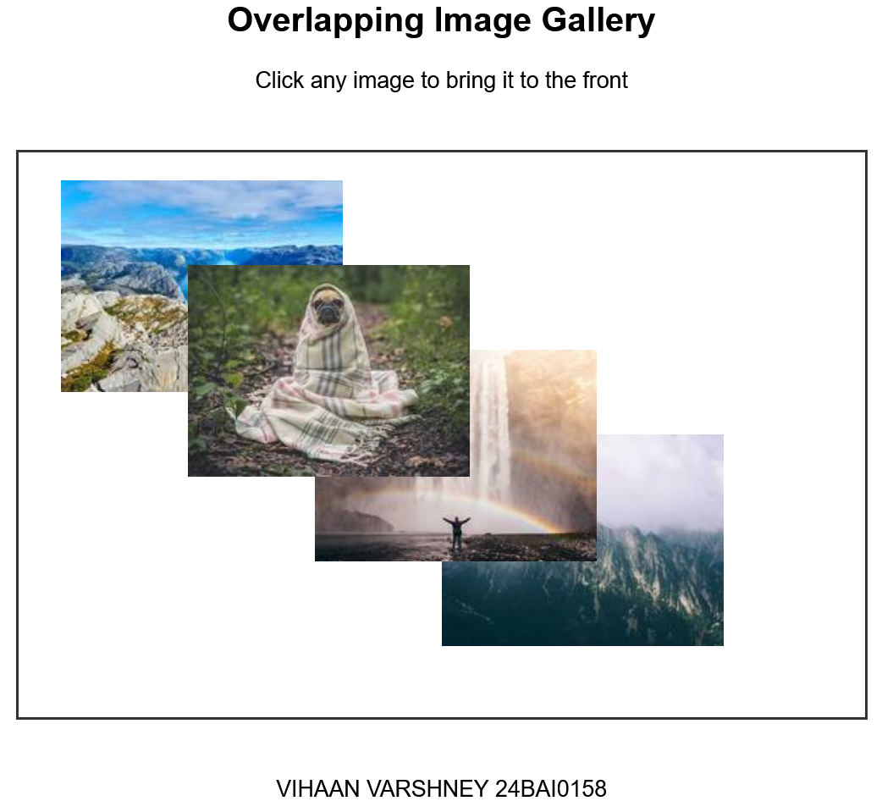
Observations | 1. The program uses `position: absolute` to allow images to overlap within the gallery container.  2. The CSS `z-index` property controls the stacking order of overlapping images.  3. A global variable `topIndex` keeps track of the highest stacking order.  4. The prefix increment operator `++` increases the z-index each time an image is clicked.  5. JavaScript dynamically updates the clicked image's z-index so it appears in front of other images.
References

